WAF Project Report on

“Online Grocery Shop”



Submitted to the PES University, 100 Feet Ring Road, BSK III Stage, Bengaluru – 560085,

in partial fulfillment of the requirement for the award of the degree in
Master of Computer Applications (2nd semester)

Submitted by: MUTHESH K USN: PES1PG25CA136

Under the guidance of

Ms. Shambhavi

Assistant Professor, MCA Department.

STUDENTS DECLARATION

I, MUTHESH K hereby declare that the project report entitled “ONLINE GROCERY STORE” was prepared by me during the year 2026 and was submitted to the PES University, in partial fulfillment of the requirements for the award of the Degree in Master of Computer Applications. I also declare that this project report is original and genuine and it has not been submitted to any other University for the award of any degree, diploma or other similar titles or purposes.

Date: | Signature of the Candidate
Place: | MUTHESH K

[USN: PES1PG25CA136]



CERTIFICATE

This is to certify that the project titled ― ONLINE GROCERY SHOP ‖ has been satisfactorily completed by MUTHESH K, USN No. PES1PG25CA136 in partial fulfillment of the requirements for WAF- II semester Project, for the II Semester BCA course during the academic semester of year 2026 as prescribed by PES University.

Faculty In-charge Head of the Department

Valued by

Examiner 1: Date:

Examiner 2: Centre: PES University

ABSTRACT

The Online Grocery Shop project is a comprehensive full-stack web application designed to provide users with a seamless, efficient, and secure platform to shop for groceries online. Developed using the MERN stack (MongoDB, Express.js, React.js, Node.js), this application replicates the essential features of a modern e-commerce system while maintaining simplicity, responsiveness, and user-friendliness.
The platform enables users to register, log in, browse categorized products, perform search and filter operations, add items to a cart, and proceed through a checkout process that supports multiple payment options. Orders placed are stored in the backend and can be retrieved later through a personalized order history dashboard. A key focus is placed on state management using React Context, along with authentication and authorization through JWT tokens.
Designed with a modern and colorful UI, the application includes responsive design principles, user feedback elements, and visual enhancements like logos and emojis to improve usability and engagement. This project not only emphasizes technical skills in frontend and backend development but also highlights practical knowledge in API handling, security, database management, and user-centric design.
Ultimately, this project demonstrates how full-stack technologies can be integrated to deliver a professional-grade online shopping experience tailored for the grocery domain.

ACKNOWLEDGEMENT

We take this opportunity to sincerely thank all those who supported us in the successful development and completion of our project “Online Grocery Shop Web Application.”
First and foremost, we would like to express our heartfelt gratitude to our project guide and faculty for their valuable guidance, insightful feedback, and continuous encouragement throughout the development process. Their expertise and suggestions have been instrumental in shaping this project from concept to completion.
We are deeply grateful to our institution and department for providing the necessary infrastructure and support that enabled us to explore and apply full-stack technologies in a real-world context.
A special thanks to the Open Source Community and documentation resources such as React, Node.js, Express, MongoDB, and MDN Web Docs, whose materials and tutorials provided critical support at various stages of development.
I am deeply grateful to our principal, Dr. BodhiSatvan , for his unwavering support. I also extend my sincere gratitude to our Head of the Department, Dr. Nagaraju Kilari for granting me the permission to pursue this internship project. I would especially like to thank my project guide, Ms. Panchami R, for her valuable guidance, insightful feedback, and timely suggestions at every stage of the project.

TABLE OF CONTENTS

ABSTRACT | 4
ACKNOWLEDGEMENT | 5
TABLE OF CONTENTS | 6
LIST OF FIGURES | 7
1. INTRODUCTION | 8
1.1 Problem Definition | 8
1.2 Objectives | 8-9
2. REQUIREMENT SPECIFICATION | 10
2.1 Hardware Requirements | 10
2.2 Software Requirements | 10
3. FUNDAMENTALS OF THE LANGUAGES USED | 11-13
4. ALGORITHM | 14
5. FLOWCHART | 15
6. IMPLEMENTATION | 16-81
7. RESULTS | 82-89
8. CONCLUSION | 90-93
9. REFERENCES | 94

LIST OF FIGURES

Fig 6.1: Backend Starting | 82
Fig 6.2: Frontend Starting | 82
Fig 6.3: Home page | 83
Fig 6.4: Footer page | 83
Fig 6.5: Products page | 84-85
Fig 6.6: Cart page | 86
Fig 6.7: Order History page | 87
Fig 6.8: Login and Register page | 87-88
Fig 6.9: Checkout Page | 89
Fig 6.10: Order successful page | 89

Grocery Shop Website

Introduction

Problem Definition:

In the rapidly evolving digital era, the need for convenience and efficiency has given rise to the demand for online shopping platforms. The Online Grocery Shop project aims to provide users with a seamless way to browse, select, and purchase groceries from the comfort of their homes. With the growing pace of life and the increasing use of digital services, this application addresses a real-world problem by digitizing grocery shopping and eliminating the need to physically visit stores.
This web application is a full-stack solution built using the MERN stack (MongoDB, Express, React, Node.js). It offers user-friendly navigation, category-wise product listings, secure login and registration, a dynamic shopping cart, and multiple payment options including UPI, card, and cash. The checkout process is designed to be intuitive and efficient, ensuring a positive user experience for all customers.
Beyond the core functionality, the project emphasizes responsive design, secure authentication using JWT, and efficient data management. Order history tracking, real-time cart updates, and a personalized greeting on login elevate the usability of the platform. Developed with scalability and modern UI practices in mind, the Online Grocery Shop stands as a practical and impactful software solution for everyday needs.

Objectives

The objectives of the project are clearly defined to ensure that the developed platform meets both user expectations and business requirements:

To develop a full-stack web application that allows users to conveniently shop for groceries online using a modern, responsive interface.

To implement secure user authentication and authorization using JWT (JSON Web Tokens) for safe login, registration, and protected routes like order history and checkout.

To provide dynamic product management features such as category-based filtering, search functionality, and real-time cart updates with quantity adjustments.

To enable a flexible and secure checkout process supporting multiple payment options like UPI, credit/debit cards, and cash on delivery.

To store and retrieve user-specific order data, allowing users to view their order history and receive order confirmation upon successful checkout.

To apply clean, modular code architecture using the MERN (MongoDB, Express.js, React.js, Node.js) stack and RESTful API principles for maintainability and scalability.

To ensure a positive user experience through a visually appealing UI with intuitive navigation, responsive design, and informative feedback throughout the shopping process.

2.REQUIREMENT SPECIFICATION

2.1 HARDWARE REQUIREMENTS:

Processor : Any Processor above 500 MHz

RAM : 8GB (Not a disk intensive program)

Hard Disk : User Choice (as long as dynamic memory allocation works)

Input device : Standard Keyboard and Mouse

Output device : VGA and High-Resolution Monitor

Operating system : Windows 8 and above

2.2 SOFTWARE REQUIREMENTS:

Development Requirements:

Visual Studio Code: | Code editing and project development
Node.js & npm: | Backend runtime environment and package manager
MongoDB: | NoSQL database to store user, product, and order data
MongoDB Compass: | GUI for managing MongoDB data
Postman: | Testing REST APIs
Git & GitHub: | Version control and collaboration

Runtime Requirements (for users):
Modern Web Browser : | To access and interact with the application frontend
Internet Connection : | Required for accessing hosted backend & payment APIs

Grocery Shop Website

Fundamentals of Languages Used

In building the food delivery website, three primary web development technologies were employed: HTML, CSS, and JavaScript , MongoDB used for Database. Each language plays a distinct and indispensable role in creating a functional, visually appealing, and interactive platform. Below is an in-depth exploration of these technologies, complete with code examples and justifications for their use.

HTML (HyperText Markup Language)
HTML is used to define the structure of the web pages. It provides the skeleton for elements like headings, buttons, forms, and layouts. Every visual component in the app is ultimately rendered using HTML under the hood.

CSS (Cascading Style Sheets)
CSS is responsible for the styling and appearance of the application. It is used to design a visually appealing and responsive user interface, including layout, fonts, colors, spacing, and responsiveness across devices.

JavaScript
JavaScript powers the interactivity and logic on the frontend. Using React (a JavaScript library), it enables dynamic components such as real-time cart updates, conditional UI rendering, and routing between pages.

Node.js
Node.js allows JavaScript to run on the server. It’s used for handling backend logic, such as user authentication, API routing, and processing orders. It ensures the server can handle multiple client requests efficiently.

Express.js
Express is a backend framework built on top of Node.js. It simplifies server creation and routing, helping manage HTTP requests, middleware, and integration with MongoDB.

MongoDB (with Mongoose)
MongoDB is a NoSQL database used to store and manage application data such as users, products, and orders. Mongoose (an ODM) helps interact with MongoDB using schemas and models.

Why HTML?

Foundation of the Web: HTML provides the structural backbone for any website. Without it, web pages would lack organization and meaning.
Cross-Browser Compatibility: HTML ensures consistency across different browsers, making content universally accessible.
Ease of Use: With a simple syntax and readability, HTML is accessible to developers at all skill levels
Integration with Other Technologies: HTML works seamlessly with CSS and JavaScript, enabling developers to create dynamic and visually appealing websites.

CSS (Cascading Style Sheets)

CSS Overview:

CSS is a styling language used to control the presentation of HTML elements. It enables developers to design aesthetically pleasing web pages by managing layouts, colors, fonts, and responsive behaviors.

Why CSS?

Improved Design: CSS transforms basic HTML structures into visually appealing designs, enhancing user experience.
Separation of Concerns: By keeping content (HTML) separate from design (CSS), developers achieve cleaner code and easier maintenance.
Responsive Design: CSS allows websites to adapt seamlessly to different devices and screen sizes through features like media queries.
Performance Optimization: External CSS files reduce redundancy and enable faster page loading by caching stylesheets.

JavaScript (JS)

JavaScript Overview

JavaScript is a versatile programming language that powers interactivity on websites. It adds dynamic behavior to static pages, enabling features like form validation, interactive menus, and real-time updates.

Why JavaScript?
Interactivity: JavaScript transforms static pages into dynamic, user-friendly interfaces by enabling client- side scripting.
Asynchronous Capabilities: Through AJAX and Fetch API, JavaScript facilitates real-time data exchange without reloading pages.
Wide Compatibility: JavaScript runs on all modern browsers, ensuring universal accessibility.

Extensibility: With frameworks like React and Vue.js, JavaScript scales easily for complex applications.

Event Handling: JavaScript allows developers to respond to user actions like clicks, hover events, and form submissions.
By combining HTML, CSS, and JavaScript, the food delivery website achieves a harmonious balance of structure, style, and interactivity. Each language plays a pivotal role in creating a platform that is not only functional but also engaging and accessible. Together, they form the backbone of modern web development, enabling a seamless user experience that meets the demands of today’s digital landscape

Algorithm and Flowchart

Algorithm:
Step 1: Start the application.
Step 2: User registers or logs into the system using email and password.
Step 3: Backend verifies credentials and returns a JWT token if valid.
Step 4: Token is stored in local storage and used for authenticated requests.
Step 5: User browses products, filtered by category or search query.
Step 6: User adds products to cart (stored in context and local storage).
Step 7: User proceeds to checkout, fills address and selects payment method.
Step 8: Order details are submitted to the server with token authorization.
Step 9: Server validates token, stores the order in MongoDB, and returns confirmation.
Step 10: User can view past orders from order history page.
Step 11: User may log out, which clears the token from local storage.
Step 12: End.

Flowchart:
. 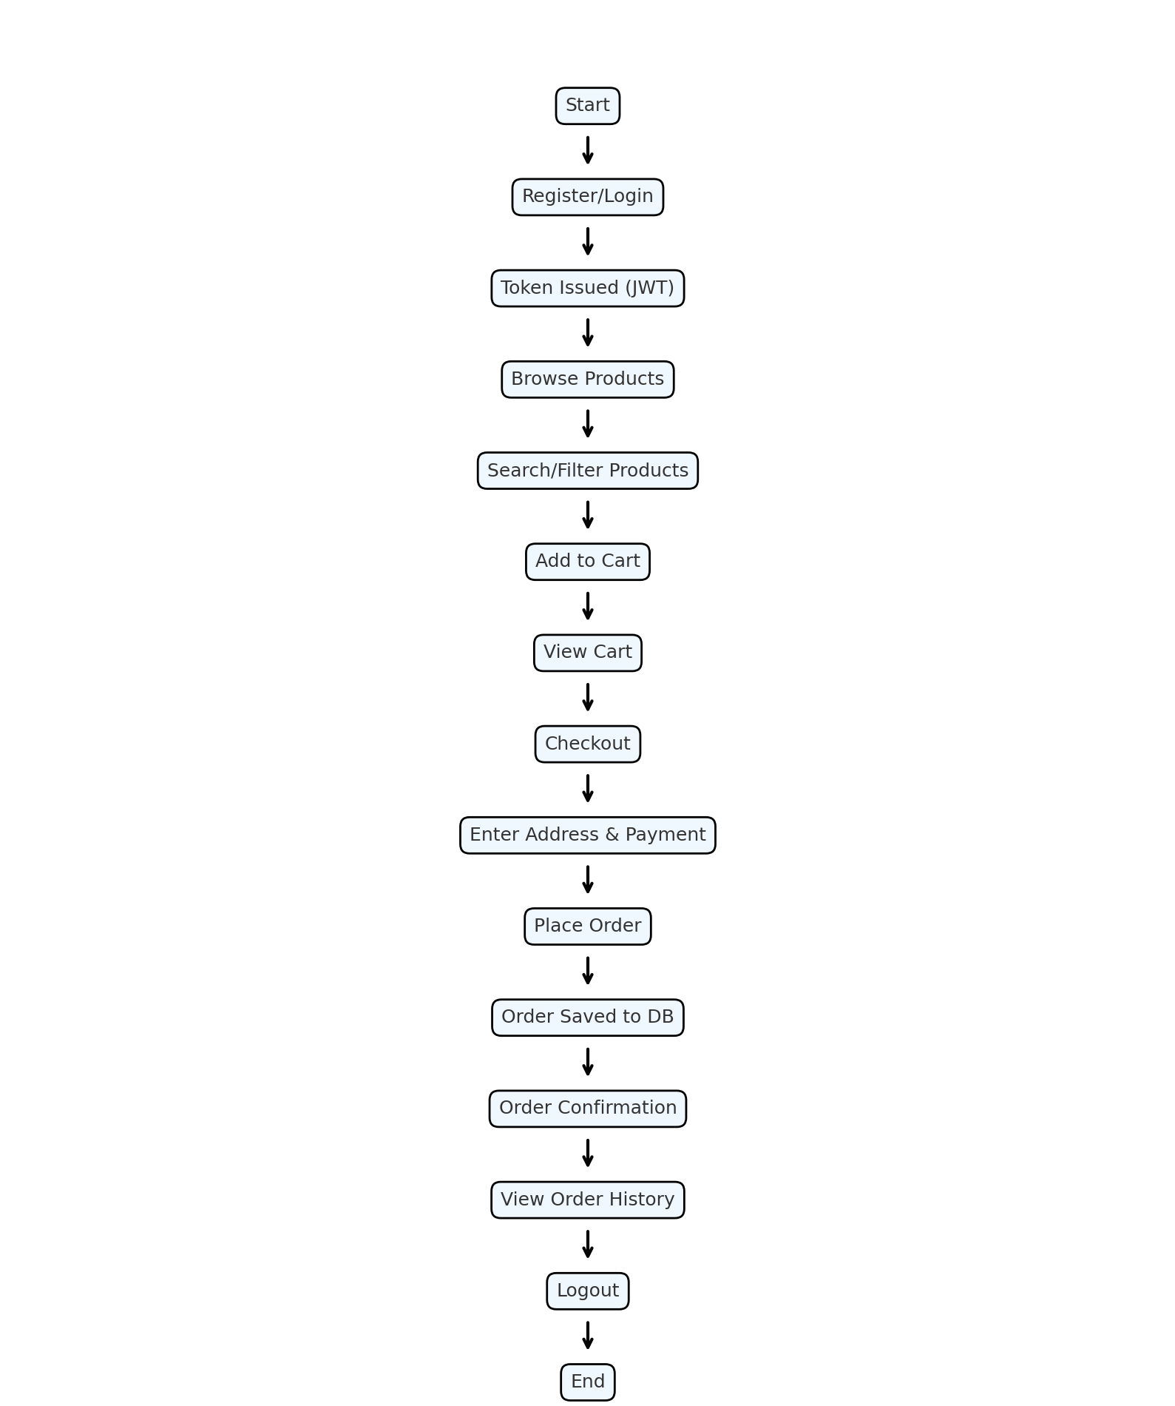

Grocery Shop website

Implementation

Homepage:

The homepage serves as the user’s first point of interaction with the Grocery Shop website. It is designed to be visually engaging and functional, providing users with an overview of available services, featured Products, and navigation links to other sections of the site.

Features:

.
      - Search Bar: Allows users to search for dishes or restaurants.
      - Featured Products: Highlights popular menu items with images, descriptions, and “Add to Cart” buttons.
      - Navigation Bar: Provides quick access to other pages such as Categories, Orders, etc
      - Footer: Contains contact information and Credits.

Development Steps

      - HTML Structure:
Form fields for gathering user input.
Integration of a Google Map iframe for location visualization.

CSS Styling:
Ensures a visually pleasing layout with a professional appearance. Highlights form validation errors to guide users.

JavaScript Functionality:
Validates user inputs, ensuring only complete and accurate submissions. Provides real-time feedback upon form submission.

Benefits

      - Enhanced User Experience: Simplifies communication for users.
      - Better Insights: Collects user feedback to improve services.
      - Brand Reliability: Showcases a responsive and user-focused approach.

Challenges

      - Spam Submissions: Requires measures like CAPTCHA to prevent unnecessary submissions.
      - Responsiveness: Ensures quick and effective customer support.

1. Pages (src/pages/)
These are the main user-facing pages of the app, rendered via React Router.
Home.js: Landing page with an introduction, features, and a call-to-action button to shop.
Products.js: Displays all grocery items with category dropdown and search filter. Includes “Add to Cart” functionality.
Cart.js: Shows all items added to the cart, with options to remove or modify quantity.
Checkout.js: Lets the user enter delivery address and choose a payment method (UPI, Card, Cash). Handles order submission.
OrderConfirmation.js: Displays a confirmation message after a successful order with summary.
OrderHistory.js: Lists all previous orders placed by the logged-in user with item and order details.
Login.js: Allows users to login using their email and password. Authenticates via the backend API.
Register.js: User signup form. After registration, redirects to the products page.

2. Components (src/components/)
Navbar.js: Top navigation bar with links (Home, Products, Cart, Orders, Login/Logout). Displays “Welcome, User”.
Footer.js: Sticky footer with contact information and developer credits.
ProductCard.js (optional): Individual product card used in the Products page.

3. Context (src/context/)
Handles global state for the shopping cart, so it works across pages.
CartContext.js: Provides CartProvider and useCart hook. Includes cart, addToCart(), removeFromCart(), clearCart().

4. Utilities (src/utils/)
Stores helper functions like token handling.
auth.js: Manages token and user data in localStorage. Functions include getToken(), setToken(), removeToken(), setUser(), getUser().

5. Routing (App.js)
Defines routes using react-router-dom for navigating between all the pages.
6. Styling
Each page and component is styled using separate CSS files. App-wide styles are in App.css and index.css. Components have their own styles like Navbar.css and Footer.css.

Benefits

      - Seamless Access: Users can log in effortlessly and access features.
      - Secure Environment: Protects sensitive user information.
Data Insights: Helps understand user behavior for service optimization.

Challenges

      - Security Threats: Mitigating risks such as phishing or brute-force attacks.
      - Ease of Use: Balancing security protocols with user-friendliness.

Register Page

The registration page is crucial for converting visitors into registered users. It lays the foundation for a secure and personalized user experience.

Purpose of the Register Page

      - User Onboarding: Enables users to join the platform seamlessly.
      - Data Collection: Gathers essential information for better personalization.
      - Service Accessibility: Unlocks exclusive features for registered users.

Core Features

      - User Input Fields:
Full Name
Email Address
Password and Confirm Password
      - Terms and Conditions Checkbox: Ensures users agree to the platform’s policies.
      - Submit Button: Completes the registration process.

Development Process

      - HTML:
Provides structure for the registration form with necessary fields. Includes validation attributes to ensure correct inputs.
      - CSS:
Creates a visually appealing layout with consistent alignment. Adds hover effects to buttons for an interactive experience.

JavaScript:

Validates inputs in real-time, like checking for strong passwords. Alerts users about any errors, such as mismatched passwords.

Backend Integration:
Stores user information in a database securely.
Sends confirmation emails to verify the user’s email address.

Benefits

      - User Growth: Encourages more users to join by simplifying the process.
      - Personalization: Allows tailored services based on user preferences.
      - Enhanced Engagement: Creates a sense of belonging for users through exclusive access.

Challenges

      - Abandonment Rates: Reducing the number of users leaving mid-registration.
      - Security: Ensuring the safety of sensitive information.
      - Error Handling: Making the process smooth by providing clear guidance for errors.

Frontend Codes:

App.js:

import React from 'react';
import { BrowserRouter as Router, Routes, Route } from 'react-router-dom';

import Navbar from './components/Navbar';
import Footer from './components/Footer';

import Home from './pages/Home';
import Products from './pages/Products';
import Cart from './pages/Cart';
import Checkout from './pages/Checkout';
import OrderConfirmation from './pages/OrderConfirmation';
import OrderHistory from './pages/OrderHistory';
import Login from './pages/Login';
import Register from './pages/Register';

function App() {
return (
<Router>
<div className="app-container">
<Navbar />
<main className="main-content">
<Routes>
<Route path="/" element={<Home />} />
<Route path="/products" element={<Products />} />
<Route path="/cart" element={<Cart />} />
<Route path="/checkout" element={<Checkout />} />
<Route path="/order-confirmation" element={<OrderConfirmation />} />
<Route path="/order-history" element={<OrderHistory />} />
<Route path="/login" element={<Login />} />
<Route path="/register" element={<Register />} />
</Routes>
</main>
<Footer />
</div>
</Router>
);
}

export default App;

Index.js:

import React from 'react';
import ReactDOM from 'react-dom/client';
import './index.css';
import App from './App';
import reportWebVitals from './reportWebVitals';
import { CartProvider } from './context/CartContext';

const root = ReactDOM.createRoot(document.getElementById('root'));
root.render(
<React.StrictMode>
<CartProvider>
<App />
</CartProvider>
</React.StrictMode>
);

reportWebVi

index.css:

body {
margin: 0;
font-family: -apple-system, BlinkMacSystemFont, 'Segoe UI', 'Roboto', 'Oxygen',
'Ubuntu', 'Cantarell', 'Fira Sans', 'Droid Sans', 'Helvetica Neue',
sans-serif;
-webkit-font-smoothing: antialiased;
-moz-osx-font-smoothing: grayscale;
}

code {
font-family: source-code-pro, Menlo, Monaco, Consolas, 'Courier New',
monospace;
}

html, body, #root {
height: 100%;
margin: 0;
display: flex;
flex-direction: column;
}

.app-container {
display: flex;
flex-direction: column;
min-height: 100vh;
}

.main-content {
flex: 1;
}

App.css:

.App {
text-align: center;
}

.App-logo {
height: 40vmin;
pointer-events: none;
}

@media (prefers-reduced-motion: no-preference) {
.App-logo {
animation: App-logo-spin infinite 20s linear;
}
}

.App-header {
background-color: #282c34;
min-height: 100vh;
display: flex;
flex-direction: column;
align-items: center;
justify-content: center;
font-size: calc(10px + 2vmin);
color: white;
}

.App-link {
color: #61dafb;
}

@keyframes App-logo-spin {
from {
transform: rotate(0deg);
}
to {
transform: rotate(360deg);
}
}
.auth-container {
max-width: 400px;
margin: 2rem auto;
padding: 2rem;
background: #e3f2fd;
border-radius: 10px;
box-shadow: 0 0 8px rgba(0,0,0,0.1);
}

.auth-container input {
width: 100%;
padding: 0.7rem;
margin: 0.5rem 0;
}

.auth-container button {
width: 100%;
padding: 0.7rem;
background-color: #1976d2;
color: white;
border: none;
border-radius: 5px;
cursor: pointer;
}

.auth-container button:hover {
background-color: #1565c0;
}

footer {
background-color: #333;
color: white;
text-align: center;
padding: 1rem;
}

Checkout.js

import React, { useState } from 'react';
import { useCart } from '../context/CartContext';
import { useNavigate } from 'react-router-dom';
import axios from 'axios';
import { getToken } from '../utils/auth';
import './Checkout.css';
const Checkout = () => {
const { cart, clearCart } = useCart();
const navigate = useNavigate();
const [address, setAddress] = useState('');
const [paymentMethod, setPaymentMethod] = useState('cash');
const [upiAddress, setUpiAddress] = useState('');
const [cardDetails, setCardDetails] = useState({
number: '',
expiry: '',
cvv: '',
});
const total = cart.reduce((sum, item) => sum + item.price * item.quantity, 0);
const handleOrder = async () => {
if (!address) {
alert('Please enter a delivery address.');
return;
}
if (paymentMethod === 'upi' && !upiAddress) {
alert('Please enter your UPI ID.');
return;
}
if (
paymentMethod === 'card' &&
(!cardDetails.number || !cardDetails.expiry || !cardDetails.cvv)
) {
alert('Please fill in all card details.');
return;
}
const token = getToken();
const formattedItems = cart.map((item) => ({
productId: item._id,
name: item.name,
quantity: item.quantity,
price: item.price,
}));
const paymentDetails = {
method: paymentMethod,
...(paymentMethod === 'upi' && { upiAddress }),
...(paymentMethod === 'card' && { ...cardDetails }),
};
try {
const res = await axios.post(
'http://localhost:5000/api/orders',
{
items: formattedItems,
address,
totalAmount: total,
payment: paymentDetails,
},
{
headers: {
Authorization: `Bearer ${token}`,
},
}
);
clearCart();
navigate('/order-confirmation', { state: { order: res.data } });
} catch (err) {
console.error('Order error:', err.response?.data || err.message);
alert('Order failed. Please login again or check your network.');
}
};
return (
<div className="checkout-container">
<h2>Checkout</h2>
<label htmlFor="address">Delivery Address:</label>
<textarea
id="address"
value={address}
onChange={(e) => setAddress(e.target.value)}
rows="4"
className="checkout-input"
/>
<label htmlFor="payment-method">Payment Method:</label>
<select
id="payment-method"
value={paymentMethod}
onChange={(e) => setPaymentMethod(e.target.value)}
className="checkout-input"
>
<option value="cash">Cash on Delivery</option>
<option value="upi">UPI</option>
<option value="card">Credit/Debit Card</option>
</select>
{paymentMethod === 'upi' && (
<input
type="text"
placeholder="Enter UPI ID (e.g., user@upi)"
value={upiAddress}
onChange={(e) => setUpiAddress(e.target.value)}
className="checkout-input"
/>
)}
{paymentMethod === 'card' && (
<div className="card-details">
<input
type="text"
placeholder="Card Number"
value={cardDetails.number}
onChange={(e) => setCardDetails({ ...cardDetails, number: e.target.value })}
className="checkout-input"
/>
<input
type="text"
placeholder="Valid Thru (MM/YY)"
value={cardDetails.expiry}
onChange={(e) => setCardDetails({ ...cardDetails, expiry: e.target.value })}
className="checkout-input"
/>
<input
type="password"
placeholder="CVV"
value={cardDetails.cvv}
onChange={(e) => setCardDetails({ ...cardDetails, cvv: e.target.value })}
className="checkout-input"
/>
</div>
)}
<h3>Order Summary:</h3>
<ul className="checkout-list">
{cart.map((item) => (
<li key={item._id}>
{item.name} × {item.quantity} = ₹{(item.price * item.quantity).toFixed(2)}
</li>
))}
</ul>
<h4 className="checkout-total">Total: ₹{total.toFixed(2)}</h4>
<button className="checkout-button" onClick={handleOrder}>
Place Order
</button>
</div>
);
};
export default Checkout;

Home.css

/* src/pages/Home.css */
.home-container {
background-image: url('https://img.freepik.com/free-photo/flat-lay-lots-vegetables-with-eggs-copy-space_23-2148487794.jpg?uid=R201408335&ga=GA1.1.443569754.1743686447&semt=ais_hybrid&w=740');
background-size: cover;
background-position: center;
min-height: calc(100vh - 60px); /* Adjust based on navbar/footer height */
padding: 2rem;
position: relative;
color: white;
text-align: center;
z-index: 0;
display: flex;
flex-direction: column;
justify-content: center;
}
.home-container::before {
content: '';
position: absolute;
inset: 0;
background: rgba(0, 0, 0, 0.5); /* dark overlay for contrast */
z-index: 1;
}
.home-hero,
.home-features,
.home-cta {
position: relative;
z-index: 2;
}
.home-hero h1 {
font-size: 3rem;
margin-bottom: 1rem;
color: #ffffff;
text-shadow: 2px 2px 6px rgba(0, 0, 0, 0.7);
}
.home-hero p {
font-size: 1.2rem;
color: #dddddd;
max-width: 600px;
margin: 0 auto 2rem;
text-shadow: 1px 1px 3px rgba(0, 0, 0, 0.5);
}
.home-features h2 {
color: #aaffaa;
font-weight: bold;
margin-bottom: 1rem;
text-shadow: 1px 1px 3px rgba(0, 0, 0, 0.5);
}
.home-features ul {
list-style-type: none;
padding: 0;
}
.home-features li {
font-size: 1.1rem;
margin: 0.5rem 0;
color: #e0e0e0;
text-shadow: 1px 1px 2px rgba(0, 0, 0, 0.5);
}
.home-cta .shop-now-button {
background-color: #4CAF50;
color: white;
padding: 14px 28px;
font-size: 1.2rem;
border: none;
border-radius: 8px;
text-decoration: none;
margin-top: 2rem;
display: inline-block;
transition: background-color 0.3s ease;
}
.home-cta .shop-now-button:hover {
background-color: #388e3c;
}

Checkout.css

.checkout-container {
max-width: 600px;
margin: 2rem auto;
padding: 2rem;
background-color: #f9f9f9;
border-radius: 10px;
font-family: sans-serif;
box-shadow: 0 0 8px rgba(0, 0, 0, 0.1);
}
.checkout-container h2,
.checkout-container h3,
.checkout-container h4 {
margin-bottom: 1rem;
}
.checkout-input {
width: 100%;
padding: 0.8rem;
margin-bottom: 1.5rem;
border-radius: 6px;
border: 1px solid #ccc;
font-size: 1rem;
}
.checkout-list {
list-style: disc;
padding-left: 1.5rem;
margin-bottom: 1.5rem;
}
.checkout-total {
font-size: 1.2rem;
font-weight: bold;
margin-bottom: 1.5rem;
}
.checkout-button {
background-color: #4caf50;
color: white;
padding: 10px 20px;
font-size: 1rem;
border: none;
border-radius: 6px;
cursor: pointer;
}
.checkout-button:hover {
background-color: #388e3c;
}
.card-details {
display: flex;
flex-direction: column;
gap: 0.75rem;
margin-top: 1rem;
}

Register.js

import React, { useState } from 'react';
import axios from 'axios';
import { useNavigate } from 'react-router-dom';
import { setToken, setUser } from '../utils/auth';
import './Auth.css';
const Register = () => {
const [formData, setFormData] = useState({ name: '', email: '', password: '' });
const [error, setError] = useState('');
const navigate = useNavigate();
const handleChange = (e) => {
setFormData({ ...formData, [e.target.name]: e.target.value });
};
const handleSubmit = async (e) => {
e.preventDefault();
setError('');
try {
const res = await axios.post('http://localhost:5000/api/auth/register', formData);
setToken(res.data.token);
setUser(res.data.user);
navigate('/products');
} catch (err) {
setError(err.response?.data?.message || 'Registration failed');
}
};
return (
<div className="auth-container">
<h2>Register</h2>
{error && <p style={{ color: 'red' }}>{error}</p>}
<form className="auth-form" onSubmit={handleSubmit}>
<input
type="text"
name="name"
placeholder="Full Name"
value={formData.name}
onChange={handleChange}
required
/>
<input
type="email"
name="email"
placeholder="Email"
value={formData.email}
onChange={handleChange}
required
/>
<input
type="password"
name="password"
placeholder="Password"
value={formData.password}
onChange={handleChange}
required
/>
<button type="submit">Register</button>
</form>
<div className="auth-footer">
Already have an account?{' '}
<span onClick={() => navigate('/login')}>Login here</span>
</div>
</div>
);
};
export default Register;
Home.js

// src/pages/Home.js
import React from 'react';
import './Home.css';
const Home = () => {
return (
<div className="home-container">
<div className="home-hero">
<h1>Welcome to <span className="highlight">GroceryShop</span> 🛒</h1>
<p>Your one-stop destination for fresh, quality groceries delivered right to your door.</p>
</div>
<div className="home-features">
<h2>Why Shop With Us?</h2>
<ul>
<li>✅ Fresh fruits and vegetables, daily stocked</li>
<li>✅ Dairy, snacks, beverages & more</li>
<li>✅ Quick delivery across Food City</li>
<li>✅ Easy online ordering and secure payment</li>
</ul>
</div>
<div className="home-cta">
<a href="/products" className="shop-now-button">🛍️ Shop Now</a>
</div>
</div>
);
};
export default Home;

Products.css

.products-container {
padding: 2rem;
text-align: center;
}
.filters {
display: flex;
gap: 1rem;
justify-content: center;
margin-bottom: 2rem;
}
.filters select,
.filters input {
padding: 0.5rem;
font-size: 1rem;
border: 1px solid #ccc;
border-radius: 5px;
}
.products-grid {
display: grid;
grid-template-columns: repeat(auto-fit, minmax(220px, 1fr));
gap: 1.5rem;
}
.product-card {
padding: 1rem;
border-radius: 10px;
background-color: #f9f9f9;
box-shadow: 0 0 8px rgba(0, 0, 0, 0.1);
transition: transform 0.2s ease;
}
.product-card:hover {
transform: translateY(-5px);
}
.product-image {
width: 100%;
height: 150px;
object-fit: cover;
border-radius: 8px;
margin-bottom: 10px;
}
.add-to-cart-btn {
margin-top: 10px;
padding: 8px 16px;
background-color: #28a745;
color: white;
font-size: 0.9rem;
border: none;
border-radius: 6px;
cursor: pointer;
}
.add-to-cart-btn:hover {
background-color: #218838;
}
.cart-toast {
position: fixed;
top: 80px;
right: 20px;
background-color: #4caf50;
color: white;
padding: 12px 20px;
border-radius: 6px;
box-shadow: 0 2px 6px rgba(0, 0, 0, 0.15);
font-weight: 500;
z-index: 1000;
animation: slideIn 0.3s ease;
}
@keyframes slideIn {
from {
opacity: 0;
transform: translateY(-20%);
}
to {
opacity: 1;
transform: translateY(0);
}
}

Products.js

import React, { useEffect, useState } from 'react';
import axios from 'axios';
import './Products.css';
import { useCart } from '../context/CartContext';
const Products = () => {
const [products, setProducts] = useState([]);
const [category, setCategory] = useState('');
const [search, setSearch] = useState('');
const [successMessage, setSuccessMessage] = useState('');
const { addToCart } = useCart();
const categories = ['Fruits', 'Vegetables', 'Dairy', 'Snacks', 'Grains', 'Meat'];
useEffect(() => {
const fetchProducts = async () => {
try {
const query = [];
if (category) query.push(`category=${category}`);
if (search) query.push(`search=${search}`);
const url = `http://localhost:5000/api/products?${query.join('&')}`;
const res = await axios.get(url);
setProducts(res.data);
} catch (err) {
console.error('Error fetching products:', err);
}
};
fetchProducts();
}, [category, search]);
const handleAddToCart = (product) => {
addToCart(product);
setSuccessMessage(`✅ ${product.name} added to cart`);
setTimeout(() => setSuccessMessage(''), 2500);
};
return (
<div className="products-container">
<h2>Our Products</h2>
<div className="filters">
<select onChange={(e) => setCategory(e.target.value)} value={category}>
<option value="">All Categories</option>
{categories.map((cat) => (
<option key={cat} value={cat}>{cat}</option>
))}
</select>
<input
type="text"
placeholder="Search products..."
value={search}
onChange={(e) => setSearch(e.target.value)}
/>
</div>
{successMessage && <div className="cart-toast">{successMessage}</div>}
<div className="products-grid">
{products.length > 0 ? (
products.map((product) => (
<div key={product._id} className="product-card">
<img
src={product.image}
alt={product.name}
className="product-image"
/>
<h3>{product.name}</h3>
<p>{product.description}</p>
<p><strong>₹{product.price}</strong></p>
<button className="add-to-cart-btn" onClick={() => handleAddToCart(product)}>
Add to Cart
</button>
</div>
))
) : (
<p>No products found.</p>
)}
</div>
</div>
);
};
export default Products;

OrderHistory.css

.order-history-container {
max-width: 700px;
margin: 2rem auto;
padding: 1rem;
font-family: 'Segoe UI', sans-serif;
}
.order-history-container h2 {
font-size: 2rem;
text-align: center;
margin-bottom: 1.5rem;
color: #2e7d32;
}
.no-orders {
text-align: center;
font-size: 1.1rem;
color: #777;
}
.order-card {
background: #fff;
border: 1px solid #ddd;
border-radius: 10px;
padding: 1rem 1.5rem;
margin-bottom: 1rem;
box-shadow: 0 0 6px rgba(0, 0, 0, 0.05);
}
.order-card p {
margin: 0.3rem 0;
}
.order-card ul {
padding-left: 1.2rem;
}
.delete-all-button {
background-color: #e53935;
color: white;
padding: 10px 16px;
border: none;
border-radius: 6px;
font-size: 1rem;
cursor: pointer;
margin-bottom: 1.5rem;
display: block;
margin-left: auto;
}
.delete-all-button:hover {
background-color: #c62828;
}

Login.js

import React, { useState } from 'react';
import axios from 'axios';
import { useNavigate } from 'react-router-dom';
import { setToken, setUser } from '../utils/auth';
import './Auth.css';
const Login = () => {
const [formData, setFormData] = useState({ email: '', password: '' });
const [error, setError] = useState('');
const navigate = useNavigate();
const handleChange = (e) => {
setFormData({ ...formData, [e.target.name]: e.target.value });
};
const handleSubmit = async (e) => {
e.preventDefault();
setError('');
try {
const res = await axios.post('http://localhost:5000/api/auth/login', formData);
setToken(res.data.token);
setUser(res.data.user);
navigate('/products');
} catch (err) {
setError(err.response?.data?.message || 'Login failed');
}
};
return (
<div className="auth-container">
<h2>Login</h2>
{error && <p style={{ color: 'red' }}>{error}</p>}
<form className="auth-form" onSubmit={handleSubmit}>
<input
type="email"
name="email"
placeholder="Email"
value={formData.email}
onChange={handleChange}
required
/>
<input
type="password"
name="password"
placeholder="Password"
value={formData.password}
onChange={handleChange}
required
/>
<button type="submit">Login</button>
</form>
<div className="auth-footer">
Don't have an account?{' '}
<span onClick={() => navigate('/register')}>Register here</span>
</div>
</div>
);
};
export default Login;
OrderHistory.js

// src/pages/OrderHistory.js
import React, { useEffect, useState } from 'react';
import axios from 'axios';
import { getToken } from '../utils/auth';
import { useNavigate } from 'react-router-dom';
import './OrderHistory.css';
const OrderHistory = () => {
const [orders, setOrders] = useState([]);
const navigate = useNavigate();
useEffect(() => {
const fetchOrders = async () => {
try {
const token = getToken();
if (!token) return navigate('/login');
const response = await axios.get('http://localhost:5000/api/orders/my-orders', {
headers: { Authorization: `Bearer ${token}` },
});
setOrders(response.data);
} catch (err) {
console.error('Failed to fetch orders', err);
}
};
fetchOrders();
}, [navigate]);
const handleDeleteAll = async () => {
const confirmDelete = window.confirm('Are you sure you want to delete all your orders?');
if (!confirmDelete) return;
try {
const token = getToken();
await axios.delete('http://localhost:5000/api/orders/delete-all', {
headers: { Authorization: `Bearer ${token}` },
});
setOrders([]);
alert('All orders deleted successfully.');
} catch (err) {
console.error('Failed to delete orders', err);
alert('Failed to delete orders.');
}
};
return (
<div className="order-history-container">
<h2>Your Order History 🧾</h2>
{orders.length === 0 ? (
<p className="no-orders">You have not placed any orders yet.</p>
) : (
<>
<button className="delete-all-button" onClick={handleDeleteAll}>🗑️ Delete All Orders</button>
{orders.map((order) => (
<div key={order._id} className="order-card">
<p><strong>Order ID:</strong> {order._id}</p>
<p><strong>Total:</strong> ₹{order.totalAmount?.toFixed(2)}</p>
<p><strong>Date:</strong> {new Date(order.createdAt).toLocaleString()}</p>
<h4>Items:</h4>
<ul>
{order.items.map((item, idx) => (
<li key={idx}>
🛒 <strong>{item.name || '(Unnamed)'}</strong> × {item.quantity}
</li>
))}
</ul>
</div>
))}
</>
)}
</div>
);
};
export default OrderHistory;

Cart.js

// src/pages/Cart.js
import React from 'react';
import { useCart } from '../context/CartContext';
import { Link, useNavigate } from 'react-router-dom';
import './Cart.css';
const Cart = () => {
const { cart, removeFromCart, updateQuantity, clearCart } = useCart();
const navigate = useNavigate();
const total = cart.reduce((sum, item) => sum + item.price * item.quantity, 0);
return (
<div className="cart-container">
<h2>Your Cart</h2>
{cart.length === 0 ? (
<p>
Your cart is empty. <Link to="/products">Shop now</Link>
</p>
) : (
<>
<ul>
{cart.map((item) => (
<li key={item._id} className="cart-item">
<div className="cart-info">
<strong>{item.name}</strong> – ₹{item.price} × {item.quantity}
</div>
<div className="cart-actions">
<button onClick={() => updateQuantity(item._id, -1)}>-</button>
<button onClick={() => updateQuantity(item._id, 1)}>+</button>
<button className="remove-btn" onClick={() => removeFromCart(item._id)}>Remove</button>
</div>
</li>
))}
</ul>
<h3>Total: ₹{total.toFixed(2)}</h3>
<div className="cart-buttons">
<button className="checkout" onClick={() => navigate('/checkout')}>Proceed to Checkout</button>
<button className="clear" onClick={clearCart}>Clear Cart</button>
</div>
</>
)}
</div>
);
};
export default Cart;

OrderConfirmation.css

.confirmation-container {
display: flex;
flex-direction: column;
align-items: center;
padding: 3rem 1rem;
font-family: 'Segoe UI', sans-serif;
background-color: #f9f9f9;
min-height: 80vh;
}
.confirmation-title {
font-size: 2rem;
margin-bottom: 2rem;
color: #2e7d32;
text-align: center;
}
.confirmation-card {
background: #fff;
border-radius: 12px;
padding: 2rem;
max-width: 500px;
width: 100%;
box-shadow: 0 0 10px rgba(0, 0, 0, 0.1);
}
.confirmation-subtitle {
margin-top: 1.5rem;
font-size: 1.2rem;
color: #444;
}
.confirmation-total {
font-size: 1.3rem;
margin-top: 1.5rem;
font-weight: bold;
color: #1b5e20;
}
.confirmation-btn {
margin-top: 2rem;
padding: 10px 20px;
background-color: #4caf50;
color: white;
font-size: 1rem;
border: none;
border-radius: 8px;
cursor: pointer;
transition: background 0.3s ease;
}
.confirmation-btn:hover {
background-color: #388e3c;
}
.confirmation-card ul {
padding-left: 1rem;
margin-top: 0.5rem;
}
.confirmation-card li {
margin-bottom: 0.5rem;
}

OrderConfirmation.js
// src/pages/OrderConfirmation.js
import React from 'react';
import { useLocation, useNavigate } from 'react-router-dom';
import './OrderConfirmation.css';
const OrderConfirmation = () => {
const location = useLocation();
const navigate = useNavigate();
const order = location.state?.order;
if (!order) {
return (
<div className="confirmation-container">
<h2>❌ No Order Found</h2>
<p>Please return to the products page and place an order.</p>
<button className="confirmation-btn" onClick={() => navigate('/products')}>
Back to Products
</button>
</div>
);
}
return (
<div className="confirmation-container">
<h1 className="confirmation-title">🎉 Order Placed Successfully!</h1>
<div className="confirmation-card">
<p><strong>Order ID:</strong> {order._id}</p>
<p><strong>Delivery Address:</strong> {order.address}</p>
<h3 className="confirmation-subtitle">Items:</h3>
<ul>
{order.items.map((item, index) => (
<li key={index}>
{item.name} × {item.quantity} = ₹{(item.price * item.quantity).toFixed(2)}
</li>
))}
</ul>
<h3 className="confirmation-total">Total: ₹{order.totalAmount?.toFixed(2)}</h3>
<button className="confirmation-btn" onClick={() => navigate('/products')}>Shop More</button>
</div>
</div>
);
};
export default OrderConfirmation;

Auth.css

.auth-form {
max-width: 400px;
margin: 0 auto;
padding: 2rem;
border: 1px solid #ccc;
border-radius: 10px;
background-color: #fff;
}
.auth-form input {
width: 100%;
padding: 10px;
margin-bottom: 1rem;
border: 1px solid #ddd;
border-radius: 5px;
}
.auth-form button {
width: 100%;
padding: 10px;
background-color: #0077cc;
color: white;
border: none;
border-radius: 5px;
cursor: pointer;
}
.auth-form button:hover {
background-color: #005fa3;
}
.auth-container {
max-width: 400px;
margin: 3rem auto;
padding: 2rem;
background: #ffffff;
border-radius: 10px;
box-shadow: 0 0 10px rgba(0,0,0,0.1);
font-family: sans-serif;
}
.auth-container h2 {
text-align: center;
margin-bottom: 1.5rem;
color: #333;
}
.auth-form input {
width: 100%;
padding: 10px;
margin: 0.5rem 0;
border: 1px solid #ccc;
border-radius: 6px;
font-size: 1rem;
}
.auth-form button {
width: 100%;
background-color: #4caf50;
color: white;
padding: 10px;
font-size: 1rem;
border: none;
border-radius: 6px;
cursor: pointer;
margin-top: 1rem;
}
.auth-form button:hover {
background-color: #388e3c;
}
.auth-footer {
text-align: center;
margin-top: 1rem;
font-size: 0.9rem;
}
.auth-footer span {
color: #4caf50;
cursor: pointer;
font-weight: 500;
}
Cart.css

.cart-container {
max-width: 600px;
margin: 0 auto;
padding: 2rem;
font-family: sans-serif;
}
.cart-item {
background: #f2f2f2;
margin-bottom: 1rem;
padding: 1rem;
border-radius: 8px;
display: flex;
justify-content: space-between;
align-items: center;
}
.cart-actions button {
margin-left: 6px;
padding: 5px 10px;
font-size: 14px;
cursor: pointer;
border-radius: 4px;
border: none;
}
.cart-actions .remove-btn {
background: #d9534f;
color: white;
}
.cart-buttons {
margin-top: 20px;
}
.cart-buttons button {
padding: 10px 16px;
margin-right: 10px;
font-size: 1rem;
border: none;
border-radius: 6px;
cursor: pointer;
}
.cart-buttons .checkout {
background-color: #4caf50;
color: white;
}
.cart-buttons .clear {
background-color: #999;
color: white;
}
Footer.css

/* src/components/Footer.css */
.footer {
background-color: #222;
color: #e0e0e0;
display: flex;
justify-content: space-between;
flex-wrap: wrap;
padding: 1.5rem 2.5rem;
font-size: 1rem;
font-family: 'Segoe UI', sans-serif;
position: relative;
}
.footer-left p {
margin: 4px 0;
line-height: 1.6;
}
.footer-left p span {
font-weight: 500;
color: #9effc0;
}
.footer-right {
text-align: right;
align-self: center;
font-size: 1rem;
font-weight: 600;
color: #ff6868;
}
.footer-right strong {
color: #c6c3ff;
font-weight: bold;
}

Footer.js

// src/components/Footer.js
import React from 'react';
import './Footer.css';
const Footer = () => {
return (
<footer className="footer">
<div className="footer-left">
<p><span>Contact:</span> +91 8867082099 | <span>Email:</span> muthesh2004@gmail.com</p>
<p><span>Contact:</span> +91 9380568447 | <span>Email:</span> lohithraoingoleb@gmail.com</p>
<p><span>Address:</span> 4th cross, Vivekananda nagar, Hoskote - 562114</p>
</div>
<div className="footer-right">
<p>Done By: <strong>Muthesh K</strong>, <strong>Lohith Rao Ingole</strong></p>
</div>
</footer>
);
};
export default Footer;

Navbar.css

/* src/components/Navbar.css */
.navbar {
display: flex;
justify-content: space-between;
align-items: center;
background-color: #4CAF50;
padding: 1rem 2rem;
color: white;
}
.navbar-logo {
display: flex;
align-items: center;
}
.logo-img {
height: 40px;
width: 40px;
border-radius: 50%;
object-fit: cover;
margin-right: 10px;
border: 2px solid white;
}
.logo-text {
font-size: 1.5rem;
font-weight: bold;
}
.welcome-user {
color: #e9f41e;
font-weight: 600;
font-size: 1rem;
}
.highlight {
color: #ffeb3b;
}
.navbar-links {
display: flex;
align-items: center;
gap: 1.5rem;
}
.navbar-links a {
color: white;
text-decoration: none;
font-size: 1rem;
}
.logout-button {
background-color: #e53935;
color: white;
border: none;
padding: 6px 12px;
border-radius: 4px;
cursor: pointer;
}

Navbar.js

// src/components/Navbar.js
import React from 'react';
import { Link } from 'react-router-dom';
import './Navbar.css';
const Navbar = () => {
const user = localStorage.getItem('user');
const userName = user ? JSON.parse(user).name : '';
const handleLogout = () => {
localStorage.removeItem('token');
localStorage.removeItem('user');
window.location.href = '/login';
};
return (
<nav className="navbar">
<div className="navbar-logo">
<img src="https://img.freepik.com/premium-vector/initial-monogram-logo-with-letter-style-design_1190297-42750.jpg?uid=R201408335&ga=GA1.1.443569754.1743686447&semt=ais_hybrid&w=740" alt="GroceryShop Logo" className="logo-img" />
<span className="logo-text">Grocery<span className="highlight">Shop</span></span>
</div>
<div className="navbar-links">
<Link to="/">Home</Link>
<Link to="/products">Products</Link>
<Link to="/cart">Cart</Link>
<Link to="/order-history">Orders</Link>
{user ? (
<>
<span className="welcome-user">Welcome, <strong>{userName}</strong></span>
<button className="logout-button" onClick={handleLogout}>Logout</button>
</>
) : (
<Link to="/login">Login</Link>
)}
</div>
</nav>
);
};
export default Navbar;

auth.js

// src/utils/auth.js
// Get the auth token
export const getToken = () => {
return localStorage.getItem("token");
};
// Save the token
export const setToken = (token) => {
localStorage.setItem("token", token);
};
// Remove the token
export const removeToken = () => {
localStorage.removeItem("token");
};
// ✅ Save user info
export const setUser = (user) => {
localStorage.setItem("user", JSON.stringify(user));
};
// ✅ Get user info
export const getUser = () => {
const user = localStorage.getItem("user");
return user ? JSON.parse(user) : null;
};
// ✅ Logout utility
export const logout = () => {
removeToken();
localStorage.removeItem("user");
};

CartContext.js

// src/context/CartContext.js
import React, { createContext, useContext, useEffect, useState } from 'react';
const CartContext = createContext();
export const useCart = () => useContext(CartContext);
export const CartProvider = ({ children }) => {
const [cart, setCart] = useState(() => {
const saved = localStorage.getItem('cart');
return saved ? JSON.parse(saved) : [];
});
useEffect(() => {
localStorage.setItem('cart', JSON.stringify(cart));
}, [cart]);
const addToCart = (product) => {
setCart(prev => {
const exists = prev.find(item => item._id === product._id);
if (exists) {
return prev.map(item =>
item._id === product._id ? { ...item, quantity: item.quantity + 1 } : item
);
}
return [...prev, { ...product, quantity: 1 }];
});
};
const removeFromCart = (productId) => {
setCart(prev => prev.filter(item => item._id !== productId));
};
const updateQuantity = (productId, amount) => {
setCart(prev =>
prev.map(item =>
item._id === productId
? { ...item, quantity: Math.max(1, item.quantity + amount) }
: item
)
);
};
const clearCart = () => setCart([]);
return (
<CartContext.Provider value={{ cart, addToCart, removeFromCart, updateQuantity, clearCart }}>
{children}
</CartContext.Provider>
);
};

Backend Codes:

.env

PORT=5000
MONGO_URI=mongodb://localhost:27017/grocery-shop
JWT_SECRET=s3cureK3yF0rJWT-t0kens123!

seed.js

const mongoose = require('mongoose');
require('dotenv').config();
const Product = require('./models/Product');
const categories = ['Fruits', 'Vegetables', 'Dairy', 'Snacks', 'Beverages', 'Grains'];
const sampleProducts = [];
categories.forEach((category, index) => {
for (let i = 1; i <= 8; i++) {
sampleProducts.push({
name: `${category} Product ${i}`,
description: `This is ${category} item number ${i}`,
price: (Math.random() * 50 + 1).toFixed(2),
image: `https://via.placeholder.com/150?text=${category}+${i}`,
category,
stock: Math.floor(Math.random() * 100 + 1)
});
}
});
mongoose.connect(process.env.MONGO_URI, {
useNewUrlParser: true,
useUnifiedTopology: true
}).then(async () => {
await Product.deleteMany({});
await Product.insertMany(sampleProducts);
console.log('Database seeded with products!');
process.exit();
}).catch(err => console.error(err));

server.js

const express = require('express');
const mongoose = require('mongoose');
const dotenv = require('dotenv');
const cors = require('cors');
dotenv.config();
const authRoutes = require('./routes/auth');
const productRoutes = require('./routes/products');
const orderRoutes = require('./routes/orders');
const app = express();
// Middleware
app.use(cors());
app.use(express.json());
// Routes
app.use('/api/auth', authRoutes);
app.use('/api/products', productRoutes);
app.use('/api/orders', orderRoutes);
// Connect to MongoDB
mongoose.connect(process.env.MONGO_URI, {
useNewUrlParser: true,
useUnifiedTopology: true
}).then(() => {
console.log('MongoDB connected');
}).catch(err => {
console.error('MongoDB connection error:', err);
});
const PORT = process.env.PORT || 5000;
app.listen(PORT, () => {
console.log(`Server running on port ${PORT}`);
});

authMiddleware.js

// server/middleware/authMiddleware.js
const jwt = require('jsonwebtoken');
const authMiddleware = (req, res, next) => {
const authHeader = req.headers.authorization;
// Log the raw Authorization header for debugging
console.log("AUTH HEADER:", authHeader);
if (!authHeader || !authHeader.startsWith('Bearer ')) {
return res.status(401).json({ message: 'Unauthorized: No token provided' });
}
const token = authHeader.split(' ')[1];
try {
// Decode the token using your JWT_SECRET
const decoded = jwt.verify(token, process.env.JWT_SECRET);
// Log the decoded payload for debugging
console.log("DECODED TOKEN:", decoded);
// Attach the user ID to the request
req.user = { userId: decoded.userId };
next();
} catch (err) {
console.error("JWT verification failed:", err.message);
return res.status(401).json({ message: 'Unauthorized: Invalid token' });
}
};
module.exports = authMiddleware;

auth.js

const jwt = require('jsonwebtoken');
const authMiddleware = (req, res, next) => {
const authHeader = req.headers.authorization;
if (!authHeader || !authHeader.startsWith('Bearer ')) {
return res.status(401).json({ message: 'No token provided' });
}
const token = authHeader.split(' ')[1];
try {
const decoded = jwt.verify(token, process.env.JWT_SECRET);
req.user = { id: decoded.userId };
next();
} catch (error) {
res.status(401).json({ message: 'Invalid token' });
}
};
module.exports = authMiddleware;

auth.js

const express = require('express');
const router = express.Router();
const bcrypt = require('bcryptjs');
const jwt = require('jsonwebtoken');
const User = require('../models/User');
// Register
router.post('/register', async (req, res) => {
const { name, email, password } = req.body;
try {
// Check if user exists
const existingUser = await User.findOne({ email });
if (existingUser) return res.status(400).json({ message: 'User already exists' });
// Hash password
const hashedPassword = await bcrypt.hash(password, 10);
// Create user
const newUser = new User({ name, email, password: hashedPassword });
await newUser.save();
// JWT token
const token = jwt.sign({ userId: newUser._id }, process.env.JWT_SECRET, { expiresIn: '2d' });
res.status(201).json({ user: { name: newUser.name, email: newUser.email }, token });
} catch (err) {
res.status(500).json({ message: 'Server error' });
}
});
// Login
router.post('/login', async (req, res) => {
const { email, password } = req.body;
try {
const user = await User.findOne({ email });
if (!user) return res.status(400).json({ message: 'Invalid credentials' });
const isMatch = await bcrypt.compare(password, user.password);
if (!isMatch) return res.status(400).json({ message: 'Invalid credentials' });
const token = jwt.sign({ userId: user._id }, process.env.JWT_SECRET, { expiresIn: '2d' });
res.status(200).json({ user: { name: user.name, email: user.email }, token });
} catch (err) {
res.status(500).json({ message: 'Server error' });
}
});
module.exports = router;

orders.js
// routes/orders.js
const express = require('express');
const router = express.Router();
const Order = require('../models/Order');
const authMiddleware = require('../middleware/authMiddleware');
// Place a new order
router.post('/', authMiddleware, async (req, res) => {
const { items, totalAmount, address } = req.body;
if (!items || !address || !totalAmount) {
return res.status(400).json({ message: 'Missing order details' });
}
try {
const order = new Order({
userId: req.user.userId,
items,
totalAmount,
address,
});
const savedOrder = await order.save();
res.status(201).json(savedOrder);
} catch (err) {
console.error(err);
res.status(500).json({ message: 'Failed to place order' });
}
});
// Get current user's order history
router.get('/my-orders', authMiddleware, async (req, res) => {
try {
const orders = await Order.find({ userId: req.user.userId }).sort({ createdAt: -1 });
res.json(orders);
} catch (err) {
console.error(err);
res.status(500).json({ message: 'Failed to fetch orders' });
}
});
// DELETE all orders of the logged-in user
router.delete('/delete-all', authMiddleware, async (req, res) => {
try {
await Order.deleteMany({ userId: req.user.userId });
res.json({ message: 'All orders deleted' });
} catch (err) {
console.error(err);
res.status(500).json({ message: 'Failed to delete orders' });
}
});
module.exports = router;
products.js

const express = require('express');
const router = express.Router();
const Product = require('../models/Product');
// Get all products or filter by category or search
router.get('/', async (req, res) => {
const { category, search } = req.query;
let query = {};
if (category) query.category = category;
if (search) query.name = { $regex: search, $options: 'i' };
try {
const products = await Product.find(query);
res.json(products);
} catch (err) {
res.status(500).json({ message: 'Error fetching products' });
}
});
module.exports = router;

Product.js

const mongoose = require('mongoose');
const productSchema = new mongoose.Schema({
name: String,
description: String,
price: Number,
image: String,
category: String,
stock: Number,
createdAt: {
type: Date,
default: Date.now
}
});
module.exports = mongoose.model('Product', productSchema);

Order.js

const mongoose = require('mongoose');
const orderSchema = new mongoose.Schema({
userId: {
type: mongoose.Schema.Types.ObjectId,
ref: 'User',
required: true,
},
items: [
{
productId: { type: mongoose.Schema.Types.ObjectId, ref: 'Product' },
name: String,
quantity: Number,
price: Number,
},
],
totalAmount: Number,
address: String,
status: {
type: String,
default: 'Processing',
},
createdAt: {
type: Date,
default: Date.now,
},
});
module.exports = mongoose.model('Order', orderSchema);

User.js

const mongoose = require('mongoose');
const userSchema = new mongoose.Schema({
name: {
type: String,
required: true,
trim: true
},
email: {
type: String,
required: true,
unique: true,
lowercase: true
},
password: {
type: String,
required: true
},
createdAt: {
type: Date,
default: Date.now
}
});
module.exports = mongoose.model('User', userSchema);
Grocery Shop Website

Results and Snapshots

Fig 6.1: Backend Start:

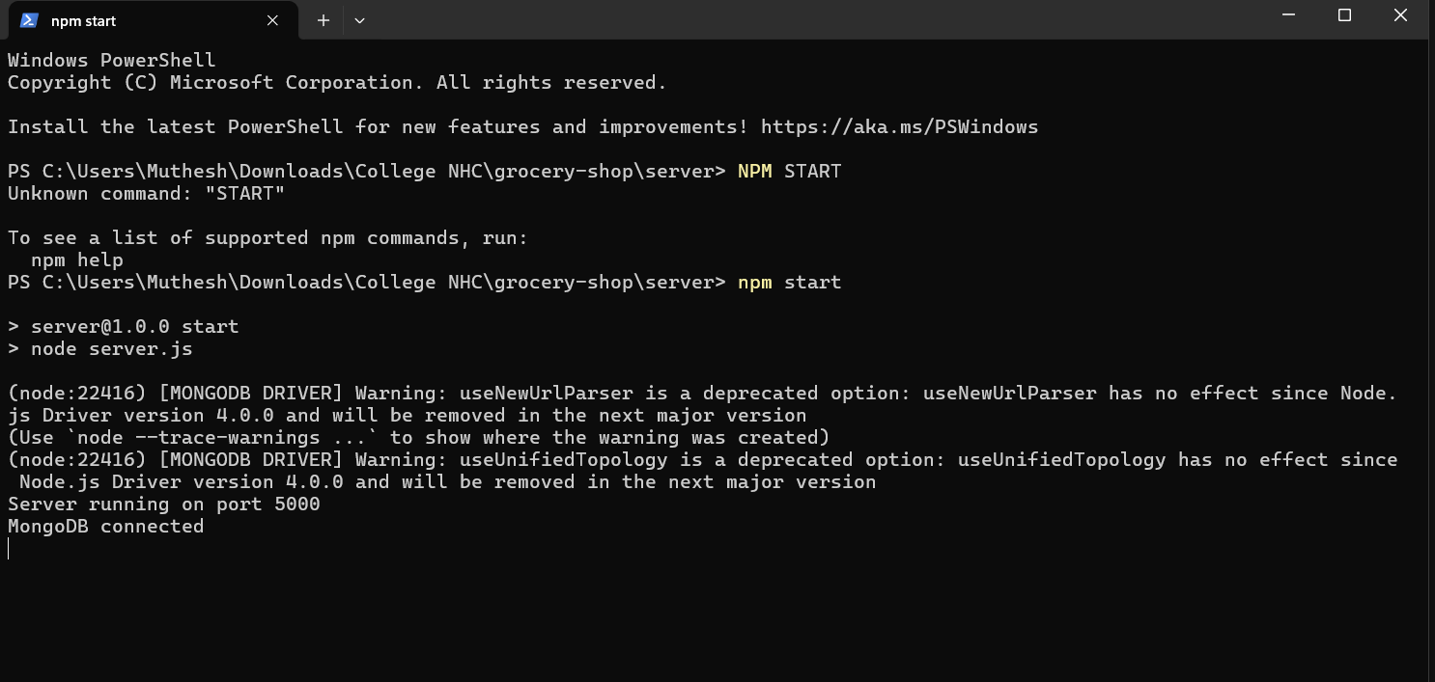

Fig 6.2: Frontend Start:

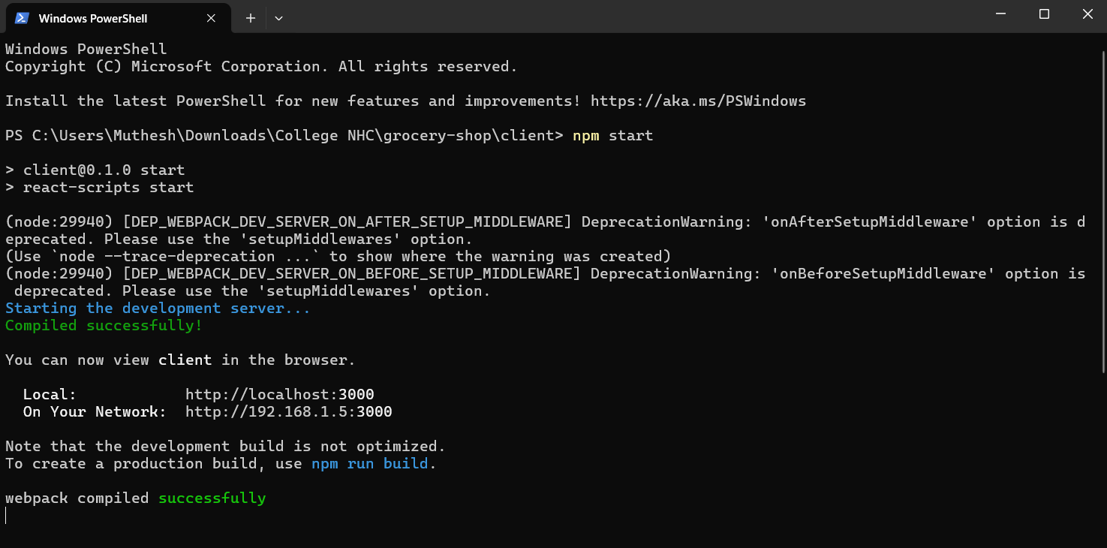

Fig 6.3: Home page:

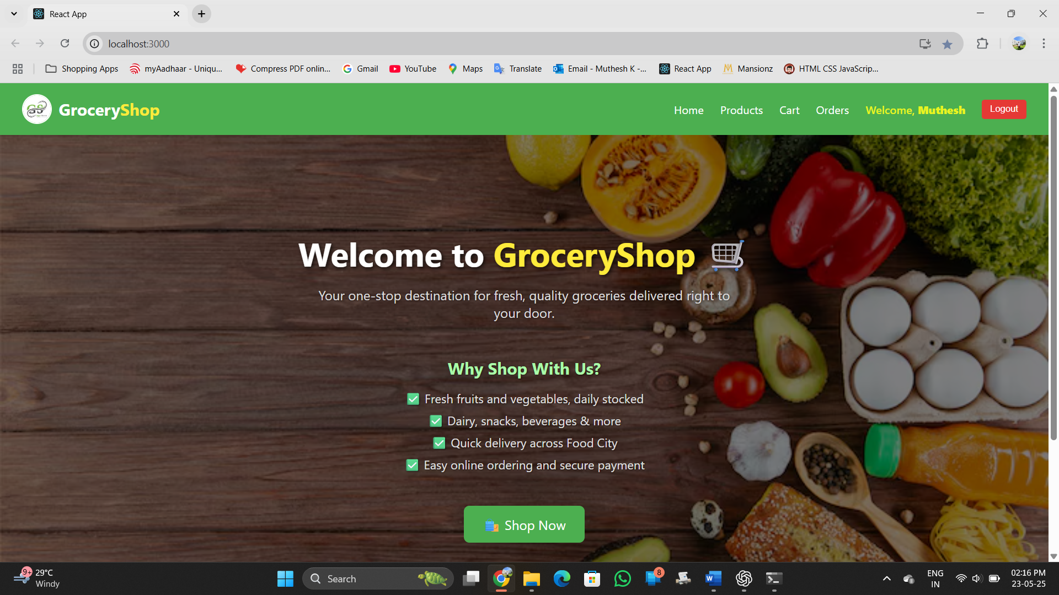

Fig 6.4: Footer page:

Fig 6.5: Products page:

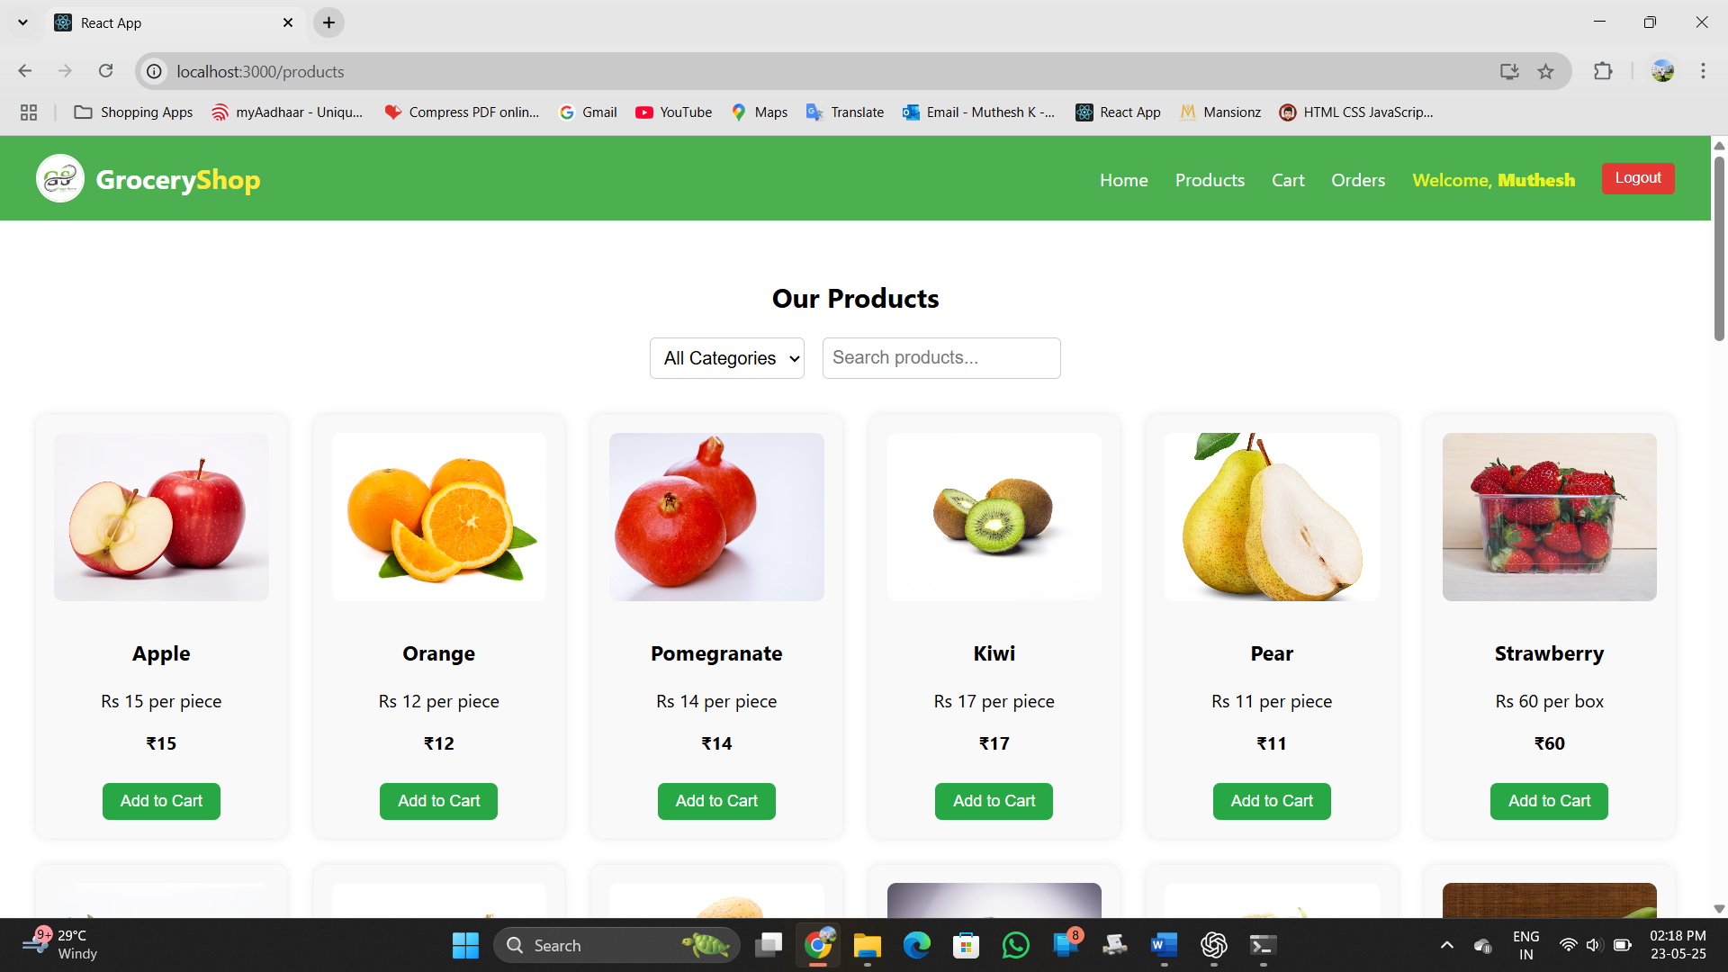

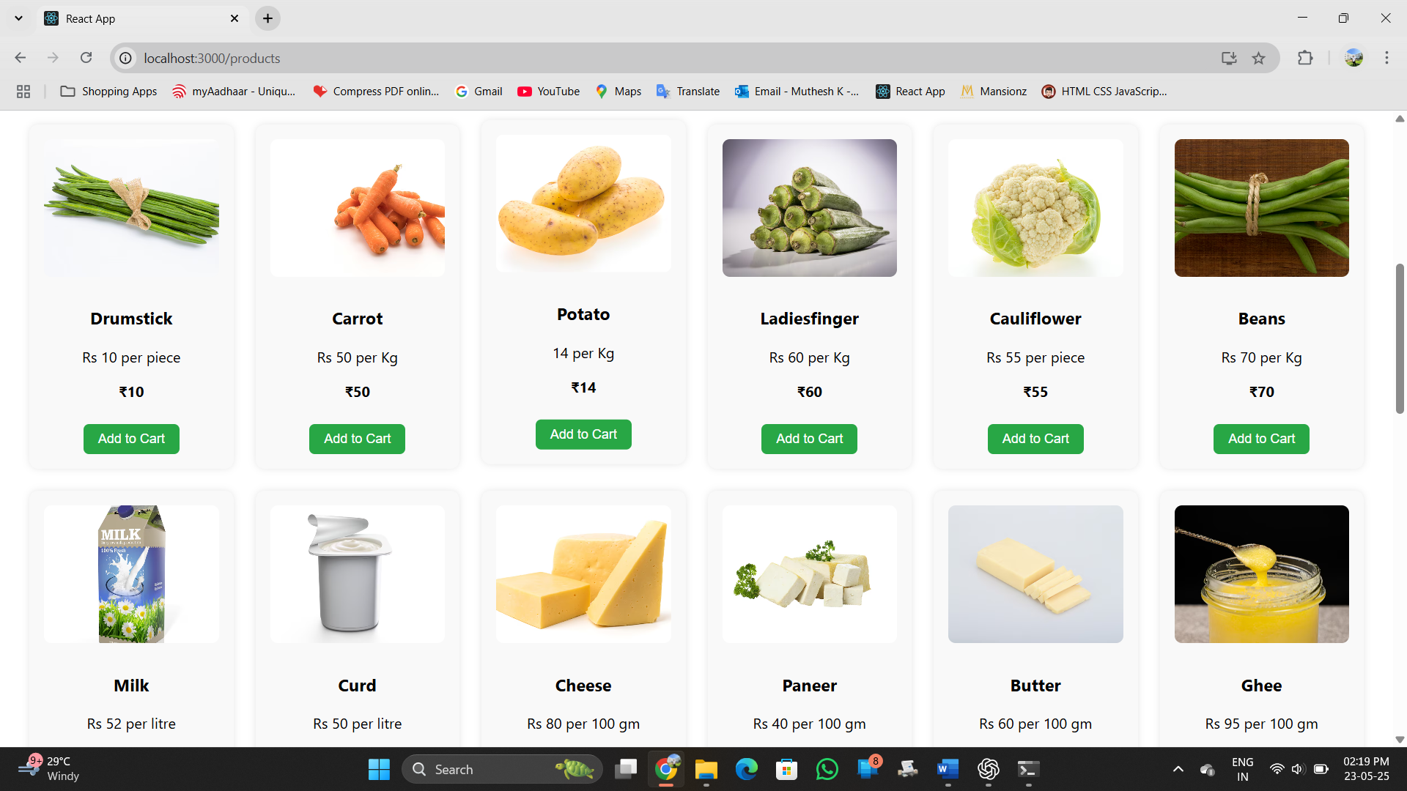

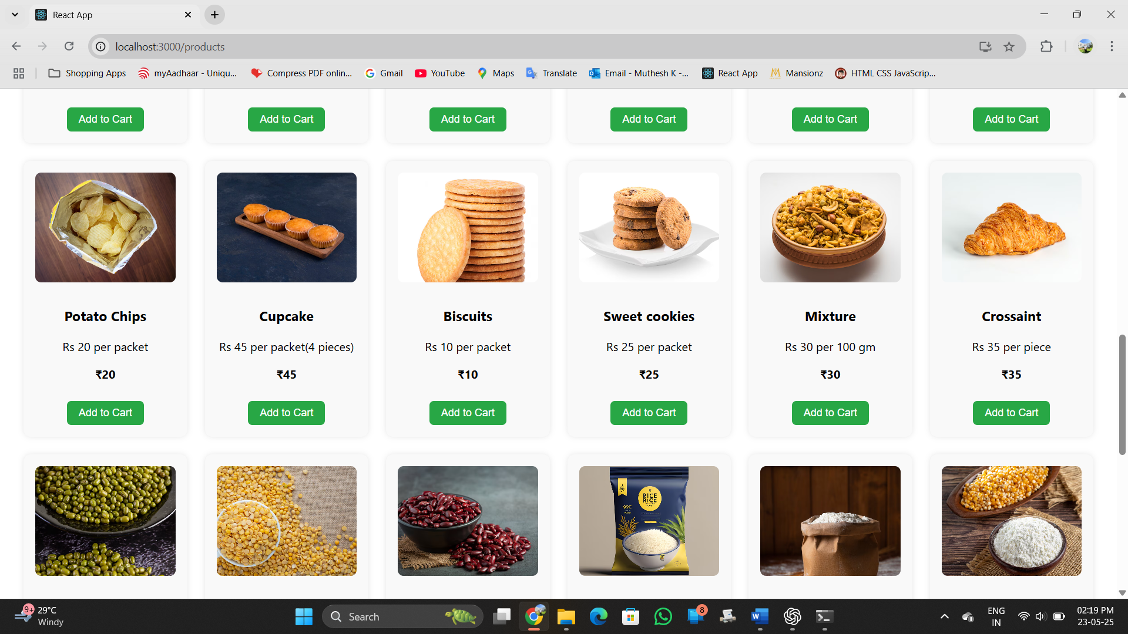

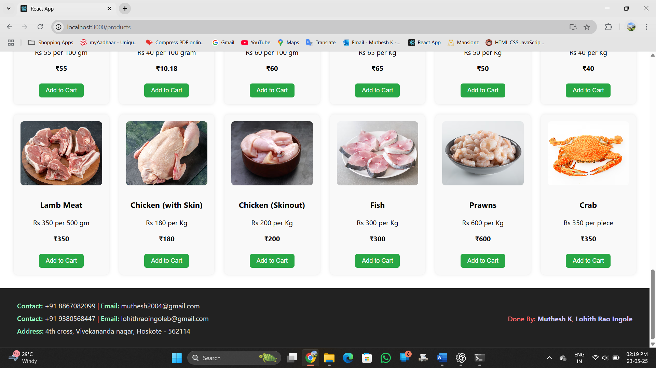

Fig 6.6: Cart page:

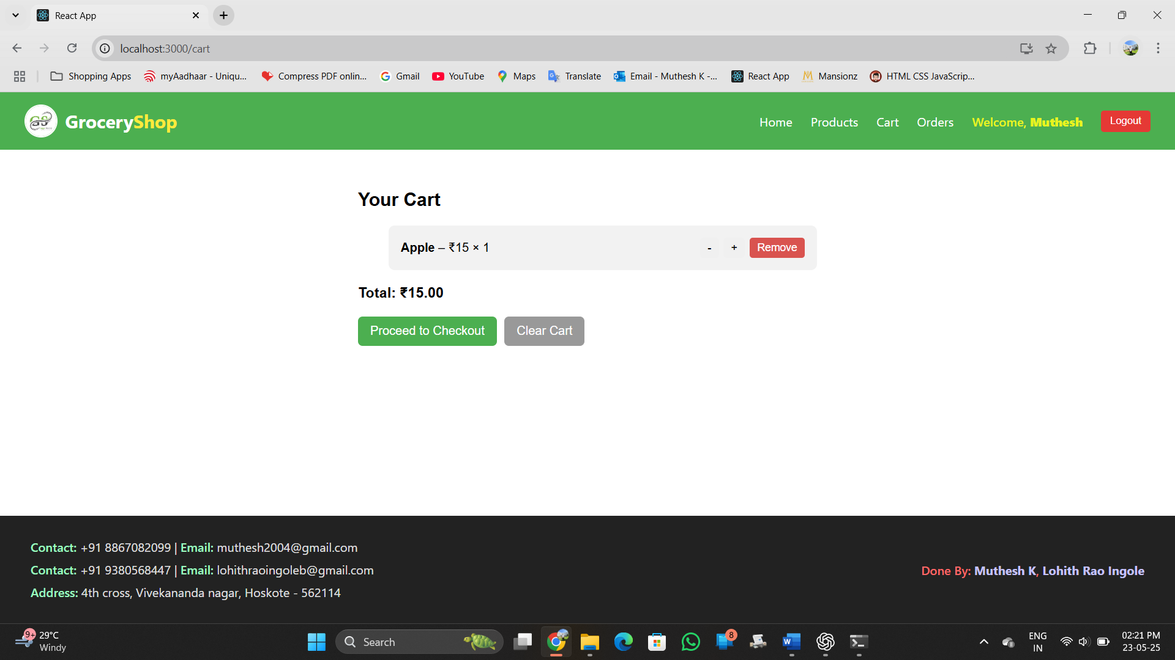

Fig 6.7: Order History page:

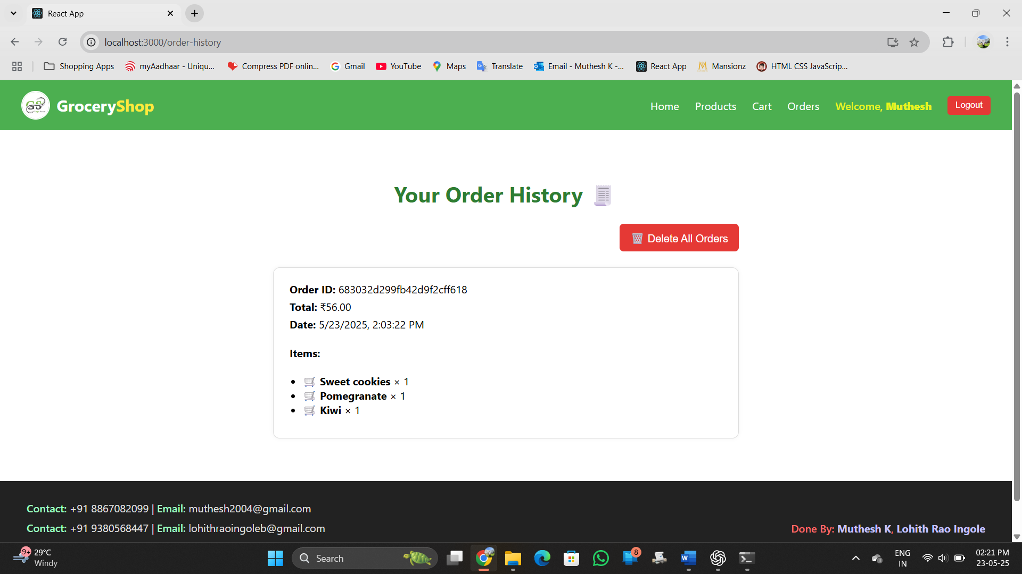

Fig 6.8: Login and Register page:

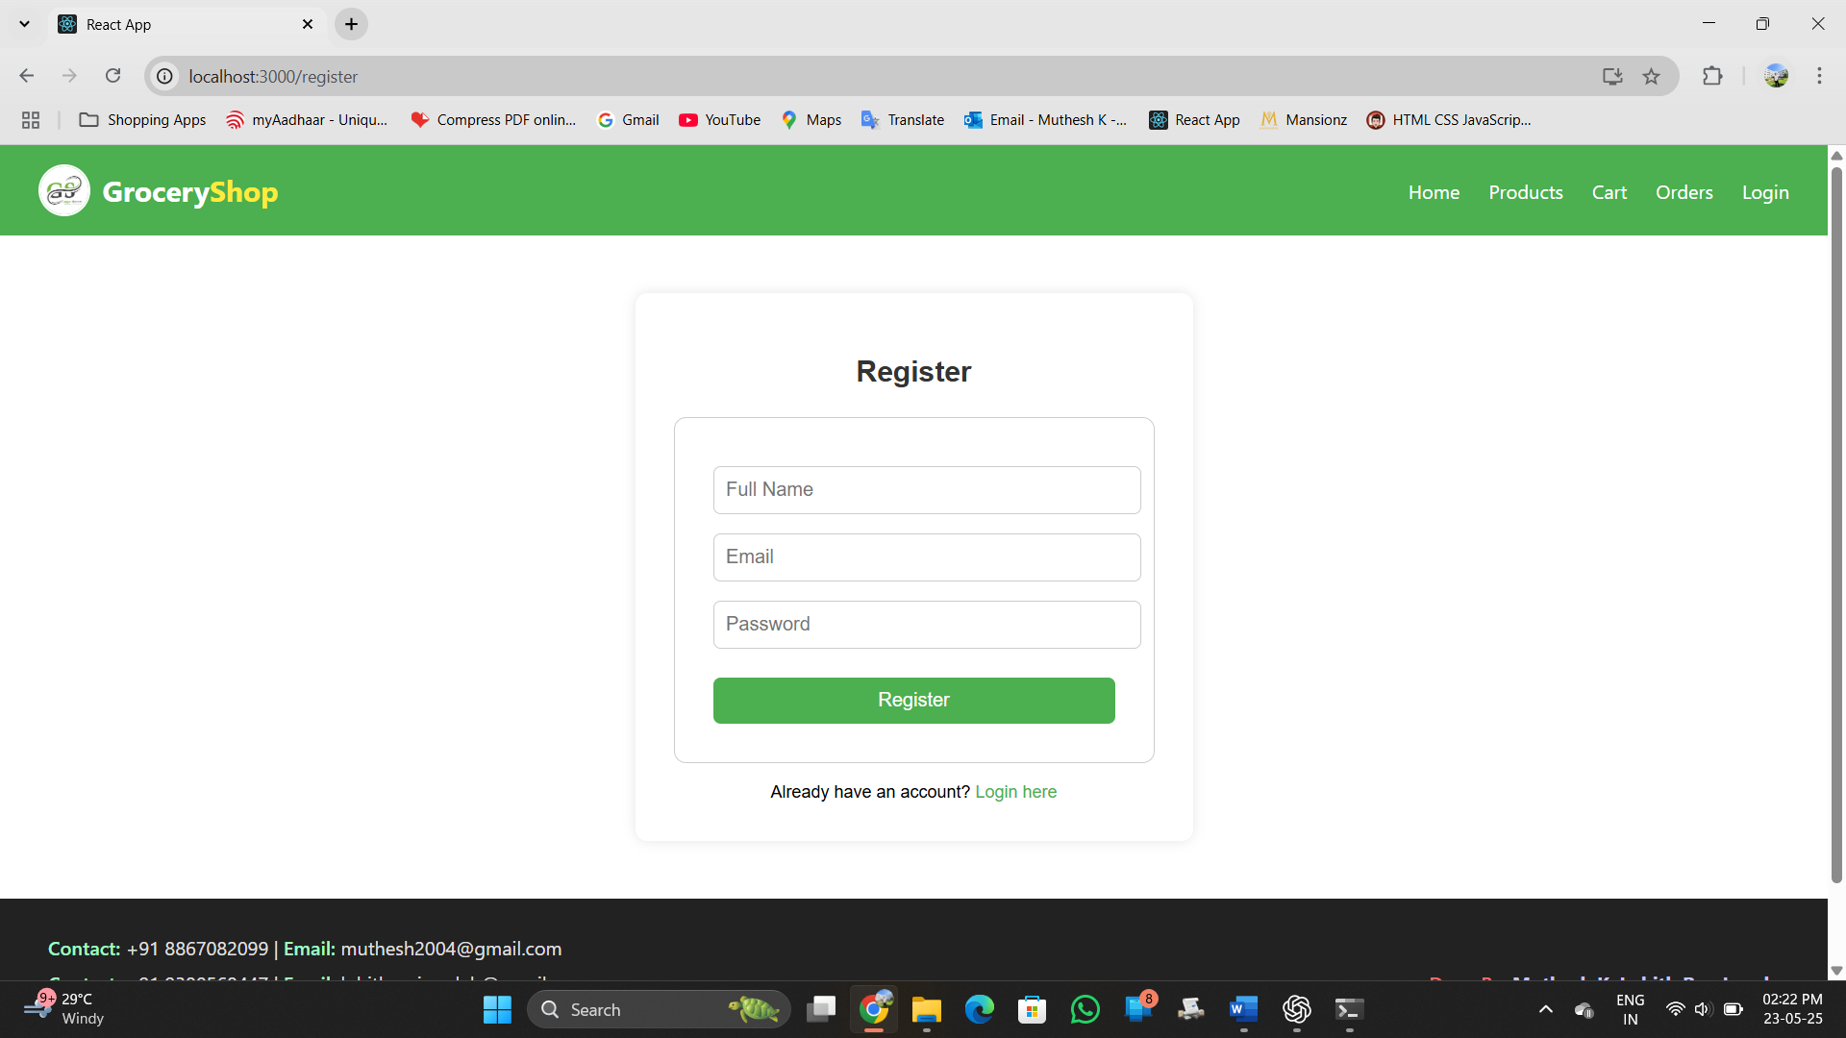

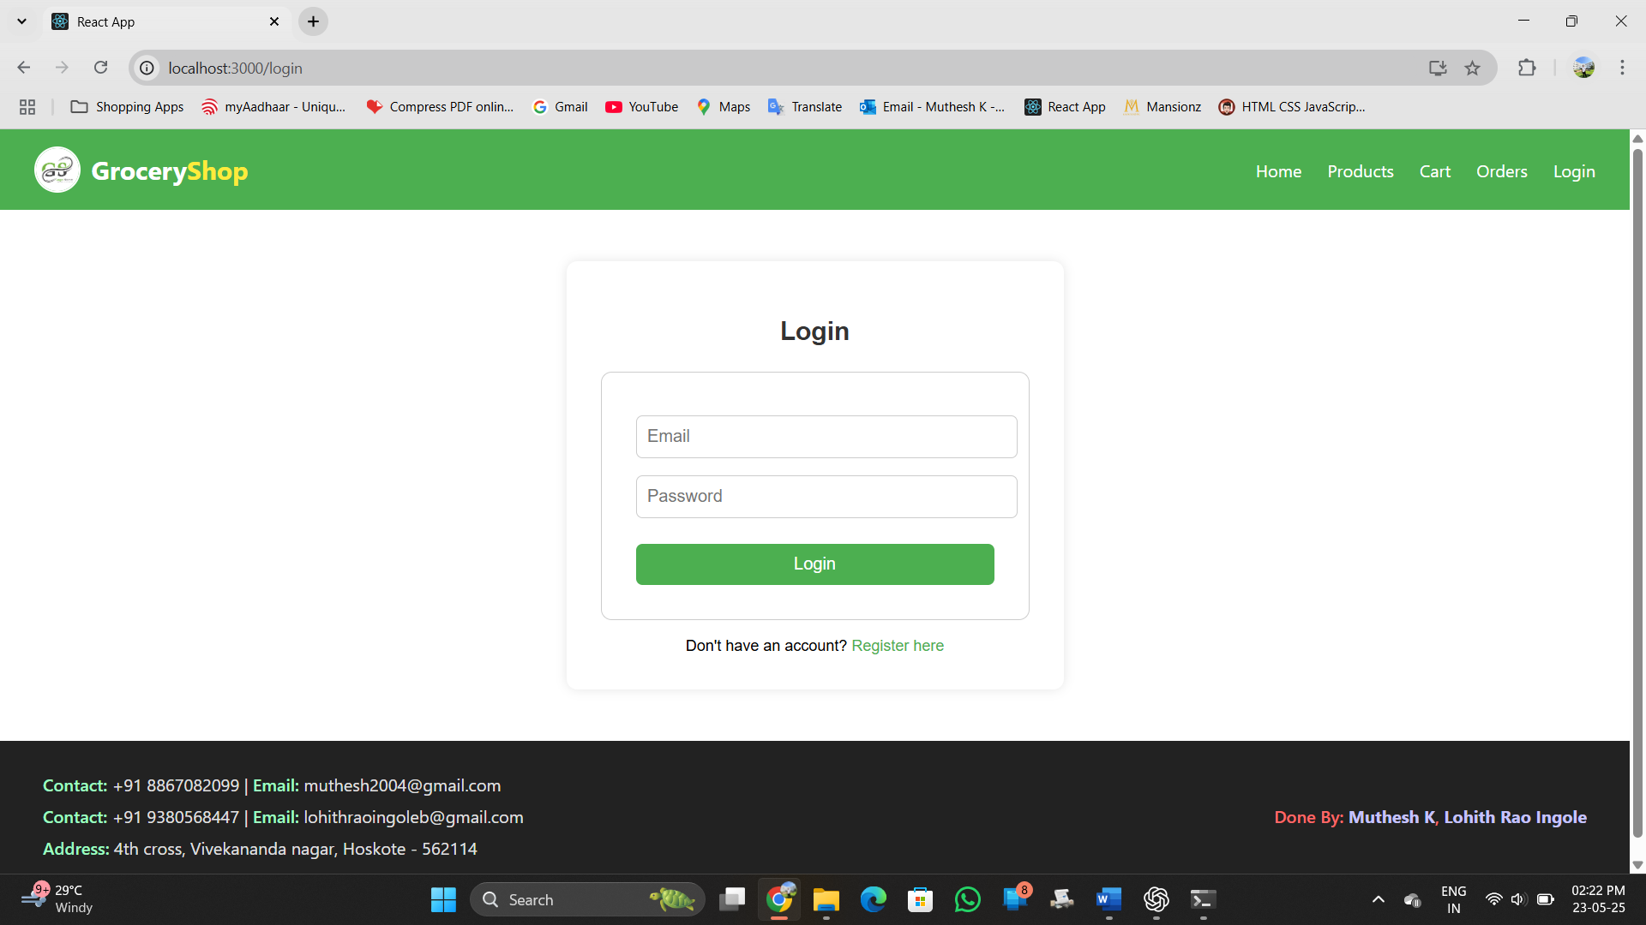

Fig 6.9: Checkout Page:

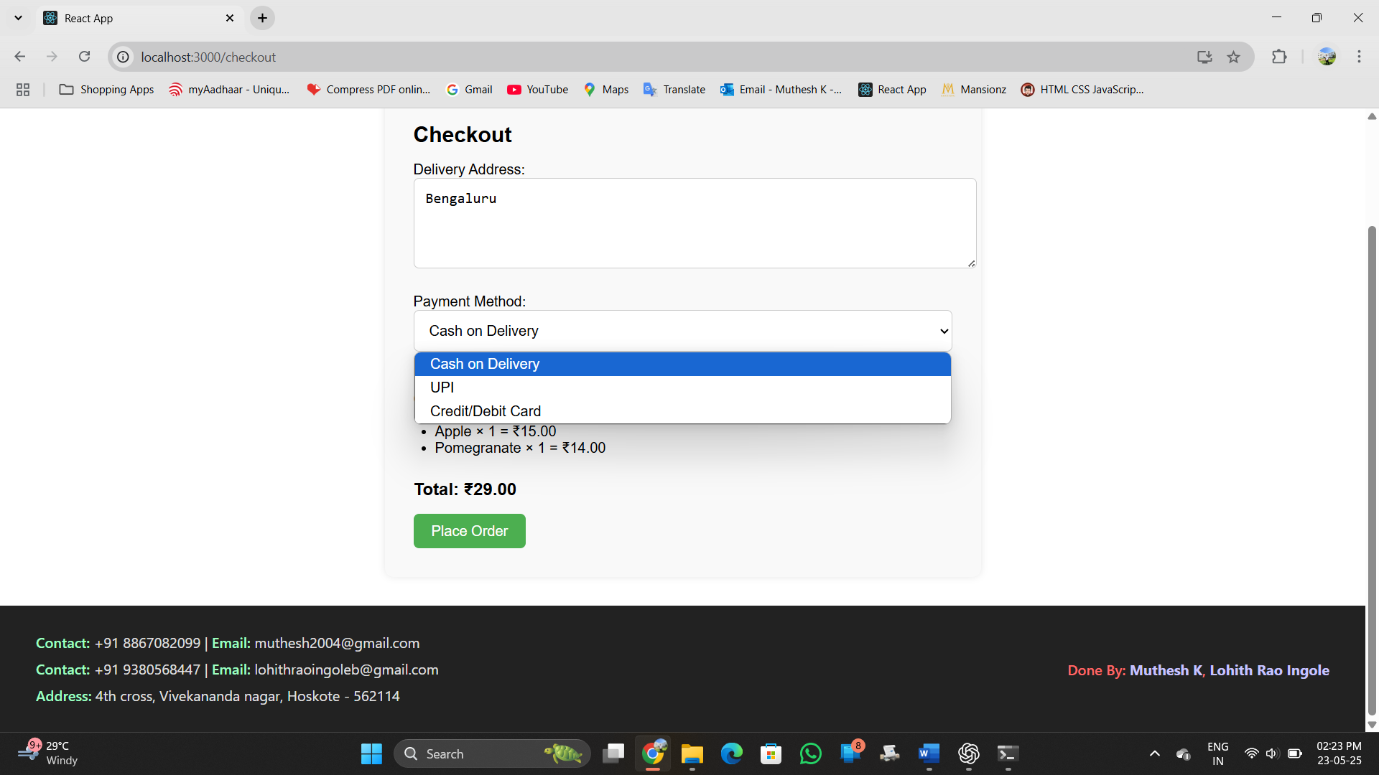

Fig 6.10: Order successful page:

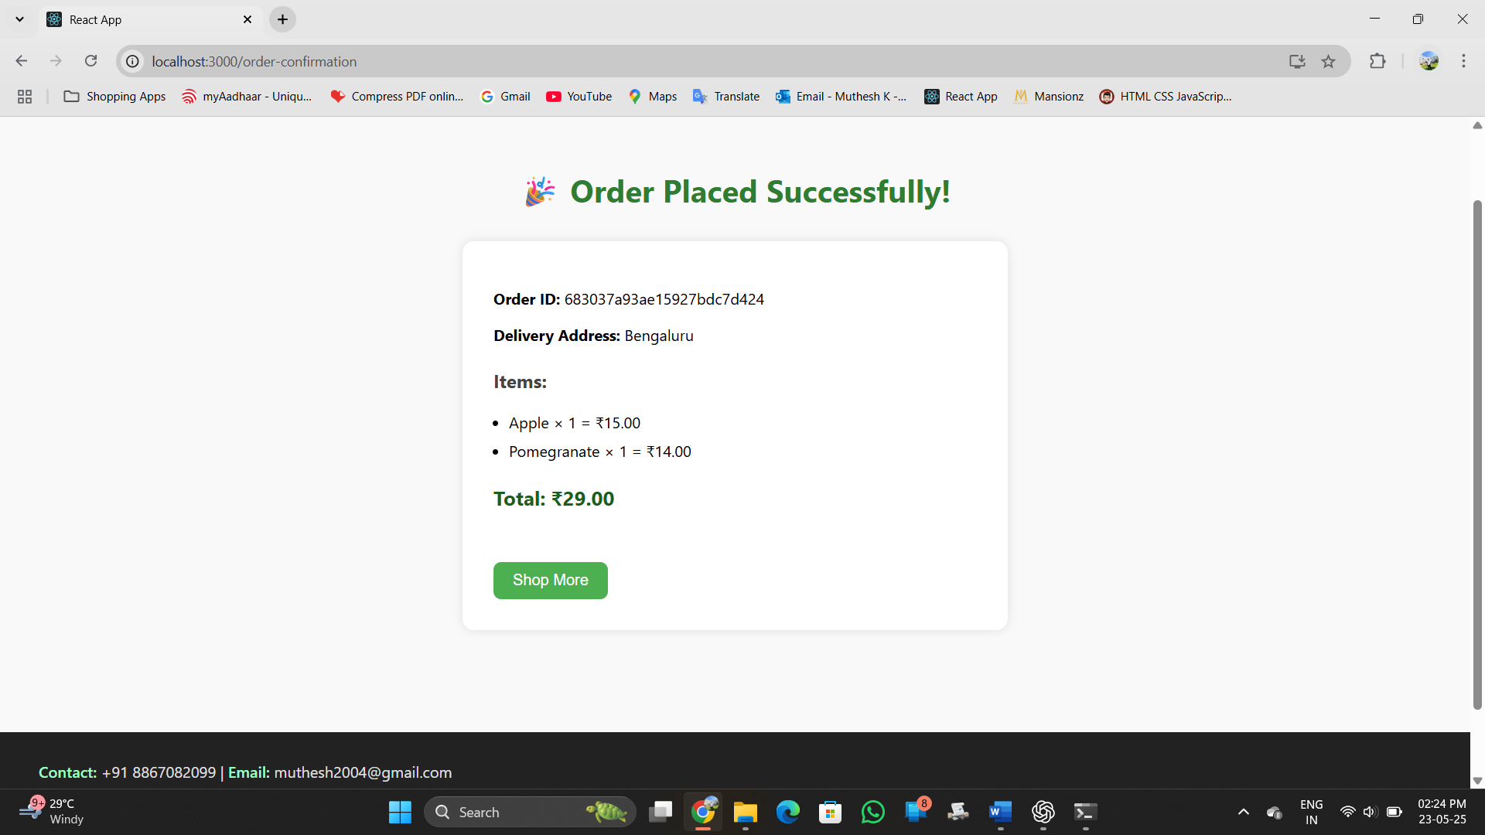
Grocery Shop Website

Conclusion

The Online Grocery Shop project has achieved its objective of delivering a complete, modern, and user-friendly e-commerce platform for grocery shopping. It incorporates a full-stack implementation using the MERN stack—MongoDB, Express.js, React.js, and Node.js. The platform supports secure user authentication, a dynamic product catalog, a real-time cart system, flexible checkout options, and persistent user order history. From frontend styling to backend API design and database modeling, each module works together to provide a smooth and efficient shopping experience.

🚧 2. Challenges Overcome
Several technical and design challenges were tackled during this project:
- State Management: Achieving seamless cart updates across pages required setting up a global context using React Context API.
- Authentication: Implementing secure, token-based login using JWTs involved managing protected routes, handling token expiration, and providing responsive error messages.
- Payment Logic: Creating dynamic forms that adapt based on the selected payment method (UPI, card, or cash) involved conditional rendering and validation logic.
- Persistent Storage: Ensuring that user and cart data remained intact between sessions demanded the use of localStorage with useEffect hooks.
- Responsive UI: Making the site mobile-friendly required fine-tuning the layout and ensuring consistent component behavior across screen sizes.

Each obstacle strengthened the architecture of the app and deepened understanding of full-stack development.

Summarizing Achievements
The Online Grocery Shop successfully delivers a full-stack e-commerce platform built with the MERN stack. Key achievements include:
- Seamless user experience with registration, login, and authentication via JWT.
- A fully functional product listing and search system with category filters.
- A responsive shopping cart integrated across the app using Context API.
- Order management system including checkout with multi-mode payments, order confirmation, and user-specific order history.
- Aesthetic UI with a modern layout, responsive components, and realtime cart updates.

⚙️ Challenges Overcome
Throughout development, several challenges were encountered and resolved:
- Authentication flow complexity was managed using JWT and local storage.
- Maintaining cart persistence across refresh and navigation was solved using Context + localStorage.
- Ensuring secure order handling required backend middleware and token validation.
- Integrating conditional UI for different payment methods required dynamic rendering logic.
- Styling and layout were tuned for cross-device compatibility using clean CSS architecture.

👥 Impact on Stakeholders
- Users: A convenient, reliable platform for grocery shopping, especially beneficial for those with limited mobility or time.
- Developers: Gained experience in full-stack development, state management, and REST API integration.
- Potential Businesses: Can adopt or extend this project to launch real-time grocery delivery services or expand their physical stores into digital platforms.

🔮 Future Scope
The project lays the foundation for further enhancements, such as:
- Admin dashboard to manage products, orders, and users.
- User profile management for editing addresses, viewing past orders, and changing passwords.
- Ratings and reviews for products.
- Discounts, coupons, and loyalty points integration.
- Real-time order tracking with notification systems (email or SMS).

💡 Key Takeaways
- Effective use of the MERN stack can power dynamic, scalable applications.
- State management via Context API is highly efficient for global states like shopping carts.
- Authentication and route protection are vital for user privacy and order integrity.
- UI/UX considerations are as important as functionality in modern web development.
- Breaking down features into components and pages improves code readability and maintenance.

🧾 Conclusion
This project represents a comprehensive solution to digitizing grocery shopping. With its clean design, modular architecture, and user-friendly features, it achieves the goal of providing a real-world e-commerce experience. More importantly, it showcases the practical application of full-stack development principles, bridging the gap between learning and real implementation.

Grocery Shop Website

References

- React Documentation
https://reactjs.org/docs
Official documentation for React – used for component development and hooks.
- Node.js Documentation
https://nodejs.org/en/docs
Used for server-side JavaScript execution and backend configuration.
- Express.js Documentation
https://expressjs.com
Used to build RESTful APIs for user authentication, product, and order handling.
- MongoDB & Mongoose Documentation
https://mongoosejs.com/docs
Used for object data modelling (ODM) with MongoDB.
- JWT (JSON Web Token)
https://jwt.io/introduction
Used for securing API routes with token-based authentication.
- MDN Web Docs (Mozilla Developer Network)
https://developer.mozilla.org
Referred to for JavaScript, HTML, and CSS syntax, best practices, and explanations.
- Freepik
https://www.freepik.com
Used for sourcing the logo and graphic icons integrated into the UI.
- Postman
https://www.postman.com
Used during backend API testing and validation.

